**HP46 *Lauren Marie***

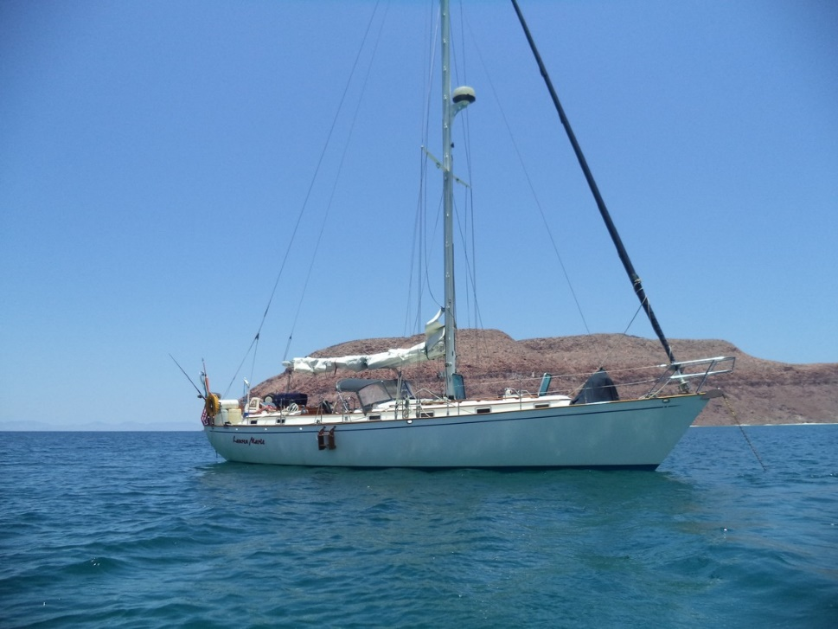

|  |  |
| --- | --- |
| **Vessel Name** | **Lauren Marie** |
| **Type** | **HP46** |
| **Year of Manufacture** | **1984** |
| **Hull Number** | **59** |
| [**HIN**](http://kp44.org.test/HIN.php)**(Hull Identification Number)** | **FBB460590684** |
| **USCG Documentation Number** | **693346** |
| **Current Location** | **Puerto Vallarta, MX** |
| **Selling Price** | **USD 150,000** |
| **Owner** | **Martin Swank** |
| **Contact (email)** | [**martinswank2012@gmail.com**](mailto:%6d%61%72%74%69%6e%73%77%61%6e%6b%32%30%31%32@%67%6d%61%69%6c%2e%63%6f%6d) |
| **Telephone** | **+1(510)849-3710** |

Documented #693346 1984 45.8’ length 6’ draft

Hull #FBB460590684 16 NRT 13’ beam FRP Fiberglass

Sold as a “Hillier Peterson 46” in Australia and a “Spindrift 46” in the USA, this 1984 Peterson Cutter is a proven offshore passage-maker – a famous design with many sea-kindly characteristics.

The *Lauren Marie* has been our family yacht since new and has been lovingly cared for. She was built to very high standards in Taiwan under the close supervision of Ron Hillier and has been well-maintained and kept in good sailing trim. She had been registered with US Documentation for international waters since new.

She is a stable and safe center cockpit performance cruiser, cutter rigged and easy to handle, considered among the best blue water cruisers. With a history of safe and comfortable voyages to Mexico, Hawaii, and California island hoping she has been an extremely comfortable liveaboard all along the way.

**ENGINE & DRIVE TRAIN**

* Inboard power is a four-cylinder Ford Lehman “Super 90” diesel engine with Borg Warner Velvet Drive transmission (2:1 reduction) that has been professionally maintained since new.
* The boat is equipped with a 22” Maxprop with new AQ22 Aqueous Metals propeller shaft, plus new cutlass and rudder bearings installation 2012. Spare fixed 3-blade bronze 19 x 18.
* There are dual Racor Turbine 500 Fuel filters with valve and manifolding for hot-swap filter changes. A 12 VDC electric fuel pump for engine priming and fuel polishing is located under the galley sink.
* Three diesel fuel tanks; (1) 316 SS custom contoured 60-gallon starboard tank (original) and (2) Polypropylene 20-gallon diesel tanks by Moeller (new 2022 West Marine) on the port side.

**ELECTRICAL**

* Most interior lighting and many navigation lights have been upgraded to LEDs. The masthead tricolor and anchor lights are LED and the spreader lights are halogen.
* The electrical system includes the main panel which has easily identifiable and professionally wired 12 VDC and 110 VAC breakers, DC and AC monitoring meters, tank level indicators, and battery switches. There is a hard-wired 1500w inverter, SI-Tech radar, and ACR 406 EPIRB.
* Radar is by Furuno.
* The Furuno autopilot has its hydraulic actuator quadrant mounted under the aft bunk and the control head mounted inside the aft companionway enabling access directly from the helm. New in 2012
* A high-output Balmar 94-165 series 160 amp alternator, a Balmar MC-614 smart charge controller provides power to 4 gel-cell batteries in a battery compartment under the settee by the chart table. A Charles UL-approved 40 amp battery charger is permanently mounted in a hanging locker adjacent to and separate from the battery compartment. A honda 2000 portable generator provides backup power generation.

**RIG, DECK GEAR, AND SAILS**

* The Forespar mast, spars, standing rigging, and halyards were installed in 2006. The last rig survey was in 2017.
* Nine oversized self-tailing winches and sturdy deck fittings improve the ease of sail handling.
* Quantum sails provided the roller furling genoa and hank on staysail. The stiff mainsail has three reefs. We also have a cruising spinnaker, Drifter, and trysail from other sailmakers.
* The dinghy is an Avon 310 RIB inflatable 4-man shore boat with Nissan 8 hp NS8B two-stroke outboard.
* The anchor windlass is a Lofrans Tigress with chain and rope gypsies and dual fore deck mounted up/down switches. A dedicated switch/breaker near the chart table activates the system.
* Anchors are a 60# CQR anchor with 250’ of 3/8” chain (on bow roller), a 20# Danforth anchor with 30” chain, and a 150’ anchor line rail mounted at the stern and additional Danforth anchor stowed in the bilge as a backup.

**BELOW DECK**

* The galley boasts a double stainless steel galley sink, a three-burner Seaward propane stove with an oven on gimbals, and a refrigerator with a large freezer cooled by a 110 VAC refrigeration compressor and belt-driven refrigeration compressor when off-shore.
* The spacious open main salon with drop leaf dining table seats eight. 15 opening port lights (new lenses and seals 2022) and 3 large deck hatches keep her light and bright. New main salon Sunbrella red upholstery 2022.
* Solid teak cabinetry, doors, and finish trim add warmth, durability, and a sense of real quality. Storage is abundant throughout the boat.
* Aft, the master stateroom has a queen bed with a sitting area and toilet ensuite providing a welcome element of privacy. The upholstery is Sunbrella blue.
* The guest stateroom in the forepeak has access to the forward ensuite and boasts a double V-berth, cabinetry, and a closet/hanging lockers. Sunbrella burgundy upholstery.

**ELECTRONICS**

* The Nav/Com station is equipped with an ICOM IC-700 SSB, 140 antenna tuner, and backstay antenna. This, teamed with an ICOM VHF panel mounted with two mobile ICOM handheld walkie-talkie units, provides abundant communications.
* Additional equipment includes an iPad with a Navionics chart plotter and GPS, Garmin handheld GPS. Explorer handheld GPS. 5” Richie Compass on steering pedestal binnacle.

**MISCELLANEOUS**

* A Whale Gusher bilge pump is mounted at the helm. A Rule 3200 GPH 12VDC float actuated model lives in the bilge under the engine and exits at deck level.
* A Spectra water maker was installed and operated for many years and then pickled around 2000 and never recommissioned. Most parts are still in place.
* There are three propane tanks: two with regulator and manifolding in the cockpit propane locker for the stove, and one in the lazarette for the BBQ. They may require certification.
* The original dodger has been restitched and functions well but the windows may need polishing.