|  |  |
| --- | --- |
| **Vessel Name** | ***Moon Slipper*** |
| **Type** | [**KP44**](http://www.kp44.org/specifications.php) |
| **Year of Manufacture** | **1977** |
| **Hull Number** | **143** |
| **Current Location** | **Rio Dulce, Guatemala** |
| **Selling Price** | **US$ 90,000** |
| **Owner** | **Mike and Glenda Wiltoni** |
| **Contact (email)** | [mike_glenda57@hotmail.com](mailto:mike_glenda57@hotmail.com) |
| **Telephone** | **+1(780) 4324339** |

**s/v *Moon Slipper***

**History**

The 44’ Kelly Peterson Cutter is a popular center cockpit cruising boat. Designed by famous naval architect Doug Peterson it is the first cruising vessel to combine outstanding sailing performance with a strong, sea kindly, and safe vessel. Its hull is built with solid GRP and is immensely strong.

We have owned Moon Slipper for the past 13 years. In that time we have cruised the NW Caribbean every winter season, returning to rest in the comfortable and economical port of Rio Dulce, Guatemala (a great hurricane hideout). From there you have many easy destinations in Mexico, Belize and the Bay Islands of Honduras. Each season we have performed regular maintenance, upgrades and maintained ongoing attention to the vessel and onboard projects. The decision to sell Moon Slipper did not come easy but it is time to move on to other adventures.

**Equipment List**

**SAILS**

* New Main
* 2 Jibs
* 1 Yankee
* Staysail
* Light air Drifter

**DECK & RIGGING**

* Sta-lok fittings and spares for Sta-loks
* Oversized Schaeffer 10 and 11 blocks on running rigging
* 1 whisker pole, 1 telescoping
* 2 Lewmar self-tailing primary sheet winches
* Barient winches and other various winches
* In-Mast Furling Main
* All running rigging is in good shape
* Lots of spare lines onboard
* Hydrovane self-steering windvane
* Stainless/wood steering wheel
* ProFurl jib roller furling
* IDEAL electric anchor windlass
* 2 bow rollers
* Custom stemhead fitting
* Shurflo anchor washdown pump

**ELECTRONICS**

* 1 – SSB radio with tuner and backstay antenna
* 1 – Uniden VHF radio
* Handheld Garmin GPS

**ELECTRICS**

* 200 watts in 3 solar panels with custom rail mount
* 12 volt battery charger
* 80 amp alternator – spare 100 amp alternator
* New 6 volt domestic battery bank
* KISS Wind Generator

**ANCHORS & GEAR**

* Chain and rope rodes
* 1 - 60 lb. CQR with 150’ 3/8” of chain and 200’ 5/8” Nylon rope
* 1 - 40 lb. Danforth with 40’ of 3/8” chain and 200’ ¾” Nylon rope
* 1 - 22 lb. Danforth
* Dinghy anchors

**DINGHY**

* 9’ AB Rib (New)
* 15 hp. Yamaha outboard (Near New)

**GALLEY AND INTERIOR**

* Adler Barber DC refrigeration
* Force 10 3-burner propane stove with oven
* Boat Interior painted white to brighten with teak trim
* Stainless steel water tanks
* 2 – 10 lb. aluminum propane tanks

**ENGINE**

* YANMAR 56 hp diesel (1500 hrs)
* Hurth Transmission
* Maxi Prop
* Manual and electric bilge pumps
* Spare whale gusher manual bilge pump for emergency use

**MISCELLANEOUS**

* Lots of dock lines
* Other cruising gear

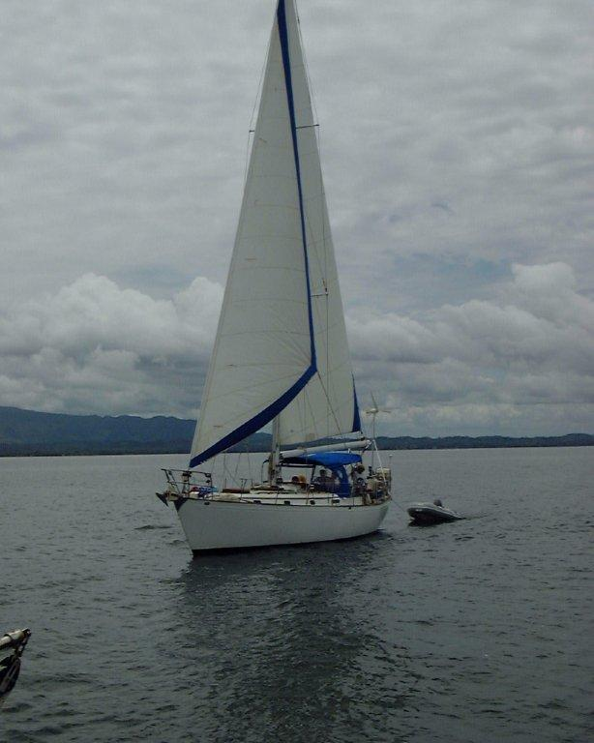**Photos**

