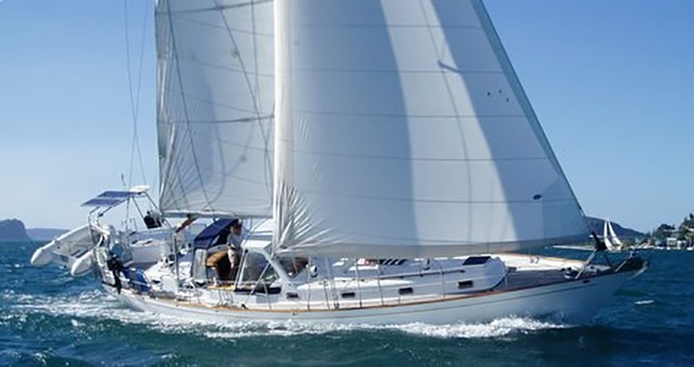

Formosa 46 *Revel* for sale

**Year:**

1982

**Length:**

45'

**Engine/Fuel Type:**

Single / diesel

**Located In:**

Indonesia

**Hull Material:**

Fibreglass/GRP

**YW#:**

20864-2999093

[Click Here for Broker’s Page](http://www.yachtworld.co.uk/boats/1982/1982-Peterson-Formosa-46-2999093/Indonesia#.V-I9l4h96M8)

**Current Price:**

US$ 105,000 Tax Paid (£ 80,757)

Revel is a superb example of the highly respected Doug Peterson designed Formosa 46. Known for their excellent sea-keeping ability and fast, efficient hulls these yachts are sought after around the world by knowledgeable yachtsman.

This yacht has been superbly maintained and fully equipped for serious blue water sailing. She had a major refit in New Zealand which included an engine rebuild, new mast and rig, new sails, a custom made dodger and hard top was added which transformed the center cockpit into a truly livable area. She's just had her engine serviced with new exhaust and alternator fitted, new lazy bag, new covers, was antifouled and new anodes fitted (August 2017) and topsides polished.

She has a beautiful warm solid teak interior in spotless condition, pride of ownership abounds wherever you look. Her electronics, sails, entire rig and much more have all been replaced and she must be seen to be appreciated. The owner is motivated to move her on to make room for another boat and is open to all reasonable offers.

**Exceptional Value at USD105,000 - Australian Tax paid**

**Boat Name**  
*Revel*  
  
**Hull**  
Solid GRP

Fin with rudder on skeg  
Length: 45ft / 13.72m

Beam: 12.92ft / 3.94m  
Maximum Draft: 6.46ft / 1.97m

Displacement: 33000 lbs./ 14969 kgs.

Ballast: 10000 lbs. / 4536 kgs

**Engine**  
Total Power: 80 HP  
Engine Brand: Ford Lehman   
Engine Model: 2712E  
Engine Type: Inboard  
Engine/Fuel Type: Diesel  
Drive Type: Shaft Drive  
Engine Power: 80 HP  
  
**Tanks**  
Fresh Water Tanks: 4 (50 Gallons)  
Fuel Tanks: 2 (75 Gallons)  
Holding Tanks: (10 Gallons)

**Interior Layout**

The interior of this Formosa 46 is stunning; the warmth of her glowing solid teak joinery and spacious layout makes her a joy to be on.

Entering the protected companionway you have a spacious U-Shaped galley to port complete with deep twin sinks, a gimbaled four burner stove and oven and ample bench and cupboards for storage.

Forward on the port side is a U shaped sofa with an extendable saloon table which can easily seat nine persons when you include the starboard sofa. The cushions are all newly upholstered in a rich royal blue.

There's a spacious double cabin up forward with adjoining head and ample locker space and storage under the bunks.

The chart table is on the starboard side and well equipped with a full suite of electronics and communication equipment.

Moving aft you have the passageway that takes you to the master cabin with its large double bed, ensuite and own companionway up to the cockpit.

The passageway contains a single bunk and additional storage, you have excellent access to the sound proofed engine room from here.

**Accommodations**

Revel has generous internal volumes;

* Number cabins: 2
* Number of double berths: 2
* Number of single berths: 1
* Number of heads: 2
* The saloon sofa to stb can also be used as a single bunk. This yacht can comfortable sleep 6 adults.

**Exterior Feature**

* Revel has been extensively equipped for blue water sailing. She had a major refit in New Zealand in 1997 which included replacing all standing and running rigging, painting, teak work, custom dodger, stainless steel arch for solar panels, davits, engine rebuild and much more.

She has solid teak side decks, teak grates in the cockpit and teak laid cockpit seats.

The new rigid dodger transforms the cockpit into a large additional well protected living space, professionally added by New Zealand shipwrights it seamlessly blends with the original coach house. It has a opening front window which allows fresh air to circulate through the cockpit and into the aft cabin.

There is a folding cockpit table mounted on the binnacle which provides the perfect spot for outside dining.

Two useful storage boxes where also added on the port and starboard quarters to house the gas bottles and provide additional storage.

Some of her equipment includes

* + Cockpit shower
  + Water Maker
  + Stainless steel Dinghy Davits
  + Stainless steel arch housing 3 x 125w solar panels
  + Stainless steel outboard motor davit
  + New Cockpit cushions
  + Foldable Cockpit table
  + 6 man Liferaft
  + Swimming ladder
  + Wind generator
  + 2.75m Australian built Aluminum bottom RIB with beach wheels
  + 5hp Tomatsu outboard
  + Solar panel 3 x 125 Watt
  + Electric windlass
  + Spray hood and full bimini with sides and clears
  + Fully enclosable lazy bag with lazy Jacks
  + Stainless gas BBQ on push-pit
  + Stainless Steel plough anchor on bow roller
  + Spare Fortress Anchor on pushpit

**Galley**

The galley features is well equipped with:

* 4 burner gimbaled stove and oven
* Microwave oven
* Manual bilge pump
* Electric bilge pump
* Refrigerator
* Freezer
* Hot Water
* Deep double stainless steel sinks
* Large surface area for prep work
* Good storage above and below benches.

**Mechanical Equipment, Spares and Tools**

Revel has a 80hp Ford Leyman engine that was completely rebuilt in 1997 and has just been serviced (Aug 2016) with a new exhaust and alternator fitted.

A brand new 2kva Generator has been installed.

There is a full set of spare parts onboard including:

* Filters.
* Fan belts
* Gaskets
* Impellors
* Extensive tools include
* Jigsaw
* Wire cutters
* Assorted fastenings
* Jumper cables
* Electric Sander
* Angle Grinder
* Sail repair kits
* Spare sheet and dock lines
* Spare electrical cable
* Jerry cans for Petrol, Water and Diesel.
* and much more.

**Electronics and Navigation Equipment**

* GME GPS GP 450
* ICOM VHF ICM45
* ICOM VHF Hand held
* ICOM SSB ICM710
* Ray Marine Radar
* Ray Marine Chartplotter - C80
* Raytheon Auto Pilot
* Raytheon Tridata
* Raytheon Wind speed and Angle
* Binnacle Compass
* Hand held Compass
* DVD player
* Log-speedometer
* Stereo and cabin Speakers
* Depth sounder

**Sails**

Revel has Hood Sails and include:

* Fully Battened Main
* Furling Jib
* Storm jib
* MPS
* Stay Sail

There is a Staysail inner forestay on a removable highfield lever

All sails were replaced in 1997, the storm and MPS have never been used and working sails have just been serviced.

Main is protected by a fully zippered lazy bag complete with lazy jacks.

All winches have been regularly serviced.

**Tender**

* Custom stainless steel davits
* 2.75m aluminium bottomed RIB with beach wheels and custom cover
* 5hp Tomatsu outboard with cover and launch system

**Safety Equipment**

Safety Equipment includes:

* 8 x Life jackets
* 2 x life rings and danbouys
* GME EPIRB
* Harnesses and life lines
* Full set of Flares (NEW)
* Fire Extinguishers throughout
* Gas Detector
* 6 Man life raft in rigid case (just serviced)
* AIS
* Sea Anchor and line
* Tow line
* Hand Held Compass
* Lead line
* Heaving lines
* Rain catcher
* Assorted fender