Specification and Inventory for

s/v Samore

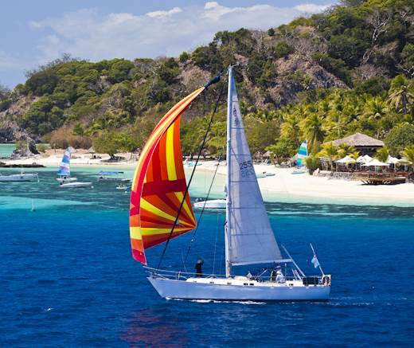

Kelly Peterson 44 Hull #255

Vessel Name | Samore
Type | Kelly Peterson 44
Year of Manufacture | 1979 in Taiwan/US for Jack Kelly Yachts
Hull Number | 255
LOA: | 43’ 10” (13.4 m)
LWL: | 38’ 8” (11.8 m)
Beam | 12’ 11” (3.8)
Draft | 6’ 4” (2 m)
Displacement | 30,000 lbs (13,068 Kg)
Sail Area | 1011 sq ft (94 m2)
Designer | Doug Peterson
Current Location | Vuda, Fiji
Selling Price | NZ$ 105,000
Owner | Andy Reid
Contact (email) | andyreid@xtra.co.nz
Telephone | +64 2102376815
Owners Comment

Samore is a Kelly Peterson 44. These boats were an amazingly successful design of their day with more than 200 being built. Hull is of solid fiberglass construction, with decks being wood cored fiberglass. Internal structure is plywood with timber subfloor.
She sails really well, easily reaching or running at 7-8 knots. She motors happily at 6.5knots. We find the central cockpit makes for easy living at anchor.
Samore was brought to Fiji by her second owner from California in 1996. Before leaving she was repowered with the current Volvo TMD31L. After cruising the islands, she carried onto Auckland for a significant refit in 2000/2001 including replacing tankage, removing teak decks. Since then she has been in Fiji and is fully imported and registered there. She was sold to a Wellington sailor in 2008 that did an extensive upgrade including re-stepping the mast, entire repaint, re-bedding and repair of systems bringing her back to fully usable condition.
Currently, she is owned by two families on an equal half share arrangement. The remaining owner bought her in 2011 and has focused on improving and maintaining mechanical and electrical systems.
She is kept at Vuda Marina, import tax paid and hauled for the hurricane season. She is fully insured.
You can find out a lot about these classic boats by visiting the Peterson cutter website www.kp44.org
Owner’s contacts
Andy Reid
Phone: +64 2102376815
Email: andyreid@xtra.co.nz
Details
Hull
Solid GRP with no evidence of osmosis at last haulout. Brand new topsides paint and boot topping March 2011. New antifouling prior to relaunch in April 2013 . Zincs replaced and thru hulls checked mid 2009. Seacocks are original ‘Groco’ barrel type. Teak capping on raised hull/deck join.
Decks
White with pale grey non-skid repainted March 2011. Teak decks professionally removed in New Zealand 2001. Internal deck drains removed and replaced with large external scupper drain holes June 2009.
Rig
Cutter rigged. Alloy mast and boom (orig) resprayed March 2011. External mainsail track plus separate tracks for pole and trysail. 3 x Lewmar 30 halyard winches (re-chromed). Substantial boom gallows (teak and s/steel)
Single line reefing for main (2 reefs) and Harken roller furling for genoa and staysail.
All new 316 stainless chainplates fitted March 2011. Standing rigging checked over and re-installed by professional rigger March/April 2011 including a new forestay and other minor defects remedied changes
Mixed running rigging 1996-2010.
Adjustable length alloy pole for downwind sailing.
Sails
Main: 1 Windjammer fully battened mains’l new 1996 serviced July 2009 (OK cond)
Headsails: Windjammer Genoa (110-130%) in good condition.
Wills No 3 high cut Genoa (2001) with 2 seasons use – beautiful sail
Windjammer stays’l in good condition
Other: Windjammer cruising chute in sock with very little use – lovely sail!
Windjammer storm jib and trys’l unused
Mechanical
Re-powered in 1996 with 100 hp Volvo Penta TMD31L. Approx. 4,000 hrs. 1¼” stainless shaft. 3 blade fixed propeller. Engine serviced continuously. New Cutless™ bearing March 2011. PSS dripless shaft seal fitted Nov 2012. Engine mounts replaced Dec 2012. Total fuel capacity approximately 160 liters in stainless tank. 2x Bulkhead mounted Racor fuel filters.
Electronics
- Uniden MC 355 fitted and Standard Horizon and-held VHF
- Uniden fixed VHF
- Uniden handheld VHF
- Humminbird 595c chartplotter/depth with Navionics South Pacific electronic charts
- Garmin hand-held GPS units
- 406 EPIRB
Electrical systems
Extensive electrical refit April 2011 by NZ registered electrician. Brand new BEP house panel and engine breaker panel and all wiring terminations. All high amperage wiring (alternator, batteries, windlass) replaced or reterminated. Voltage sensitive relay to alternator. 12v ASU fridge installed. Solar charging installed.
- 4x 70amp hr house batteries. New Oct 2011.
- 2x 70amp hr start batteries. New June 2012
- 4x solar panel rated 80 amps w/ MEP regulator. New April 2011.
- 1x 120amp marine alternator w/built in regulator new August 2011
- Internal lighting LED bulbs throughout
- 4x 12v plugs in main saloon and by chart table.
- Fixed Wi-Fi access point. Accepts Vodem with local sim card to give onboard Wi-Fi with minimal draw.
- 20amp smart shore power charger
- 250watt pure sinewave inverter
Plumbing
- Pressure water system with engine-driven hot water tank.
- Fresh water capacity is about 300 litres in two stainless steel water tanks. Stbd tank replaced in 2001, port tank repaired in 2010.
- 100 litre bladder tank plumbed via charcoal filter to dedicated drinking water faucet.
- 3x bilge pumps with individual float switches. Replumbed 2009 with new non-return valves and above water thru hulls. All head hoses replaced 2009. All rewired April 2011.
On deck
- Starting fwd, double s/steel bow rollers with heavy duty rollers lead to Lighthouse 1501 elec. windlass. Bearings and seals replaced July 2011. Windlass motor replaced Oct 2012.
- 2X anchors. Main is 20kg Bruce with 85m 3/8” galv chain (good condition). Spare is s/steel 20kg plough style with hollow shank and approx 10m chain/100m heavy duty nylon. Snubber with chain hook.
- All 14 brass ports removed and re-bedded 2009. New seals. Glass in fwd and saloon skylight hatches replaced 2009 with new lexan. Aft cabin skylight clear also recently replaced.
- Pulpit/pushpit and lifelines all around. Lifelines replaced Dec2012. Fully netted to keep kids onboard. Stanchions and chainplates resealed at deck level 2009. Track on coaming for adjustable headsail sheeting. Inner track on deck for stays’l
- Substantial mooring cleats and fairleads
Cockpit
- Teak trim in cockpit incl. coamings, seating and dodger base. All teak sanded and recoated March 2011. Teak in cockpit in poor shape.
- Pedestal mount wheel steering with chain/wire to rudder quadrant. Engine controls mounted on pedestal connecting to engine via Morse cables. Ritchie compass
- Winches:
  - 2x Lewmar ST 54 (reasonably new) primaries
  - 2x Lewmar 30 secondaries for headsails
  - Lewmar ST40 for mainsheet, Lewmar ST40
  - Barlow ST for main halyard and reefing lines
- Large cockpit locker portside. Gas locker at after end of cockpit with shutoff solenoid and locker drain. 12kg capacity.
Interior
- Interior refurbished in 2009 incl repainting/revarnishing.
- Cabin sole stripped and revarnished.
- White paint and Formica to lighten cabin area.
- All cushions recovered.
Forward Cabin
- Double berth with access to forward.
- 2x new halogens
- Hella fan
- Ample storage.
- Extra squab for comfort
Forward Heads
- Hot and cold pressure water.
- PAR electric macerating toilet with new hose 2009, new macerator 2011.
- Hand held shower with new Whale 440 Gulper pump 2009
Saloon: Consists of settee and dinette table plus copious locker and shelf space. Settee pulls out to form large single, dinette converts to double if req’d
Chart table: Full size chart table with multiple storage areas
Galley
- U shaped galley with Hillerange 3 burner stove (Oven not working).
- Pressure hot and cold water to twin sinks.
- Salt water foot pump. 2x cavernous frig/freezer compartments.
- One used as drystore; other fitted with 12v ASU3701 fridge unit in April 2011.
Aft companionway: Outboard is sail storage area, main house bank and fuel tank. Inboard are 2 sliding doors to permit engine access
Aft cabin: Large double plus hanging locker, shelf space and drawers. Sep access to cockpit. Under the bunk is a large FRP tank previously used as a holding tank
Aft Head: Hot and cold pressure water. Recent Jabsco manual toilet. No shower but provision to fit one.
Safety
- 6 person life raft re-certified 2011
- 2x inflatable lifejackets with built in harnesses. 2x std harness with tethers. Jackline straps for deck
- 3x std lifejackets
- Danbuoy/lifebuoy combo plus ‘Lifesling’ system.
- ‘Gale Rider’ drogue (unused)
- Assorted old flares, flare gun
- 2x fire extinguishers new July 2011
- 406 EPIRB
Other
- Auto-Helm windvane with auxiliary rudder (currently not fitted)
- 3.4m Southern Pacific inflatable dingy with 15hp 2 stroke Yamaha. New April 2011. Great condition.
- Shelter canvass includes cockpit dodger w/bimini connection to boom gallows aft. Currently being re-canvased. Misc covers for liferaft, windlass, main etc.
- 8x fenders incl 4 new 2009
- Extensive spares include impellers, fuel /oil filters and Vbelts for alternator. Spare bilge pump, elec. fittings and wire
- Reasonably extensive toolkit on board.
- Galley equipment incl. Pots and pans, plates, cutlery etc
- Assorted charts for Fiji and nearby Pacific Islands

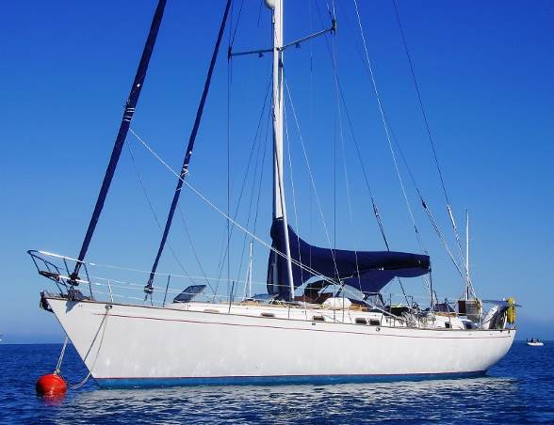
Samore at Musket Cove (2010 before repaint)

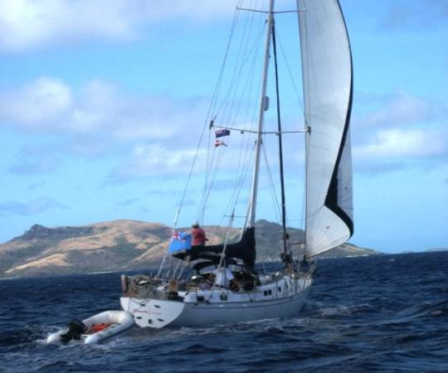
Samore sailing in Fiji (before repaint)

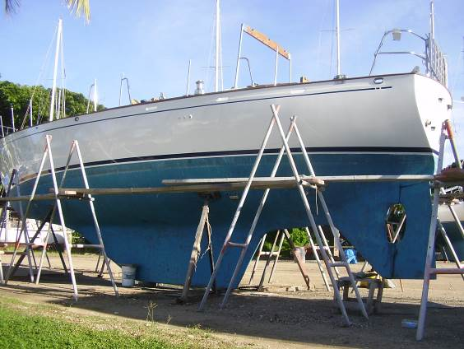
Repaint shots (March 2011)

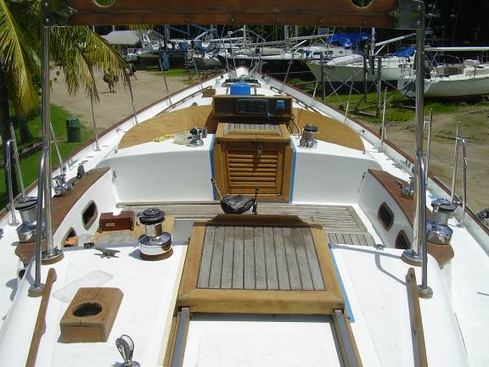
Repaint shots (March 2011)
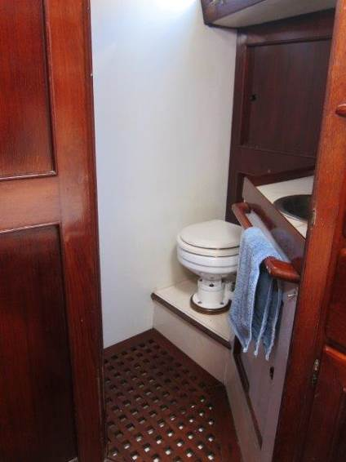
Fwd Head.
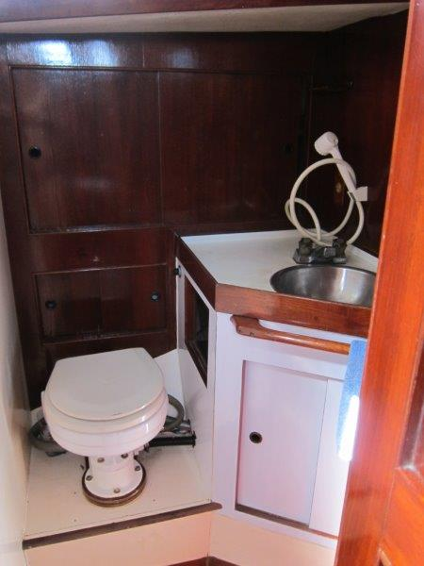
Fwd Head – TMC macerating toilet. H&C pressure water. Shower and pumped sump.
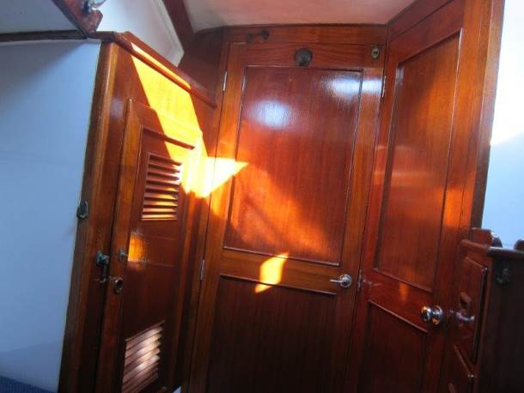
Fwd V-berth – looking aft.
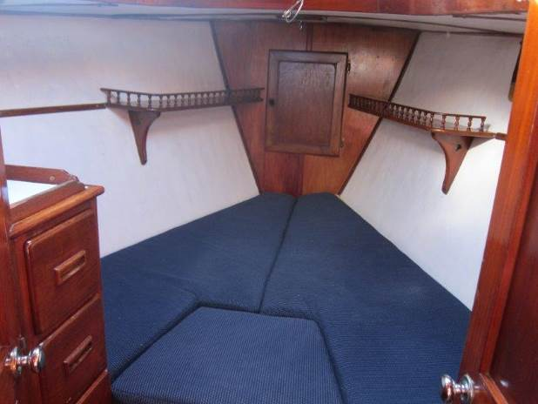
Fwd V-Berth – looking fwd. Door accesses chain locker.

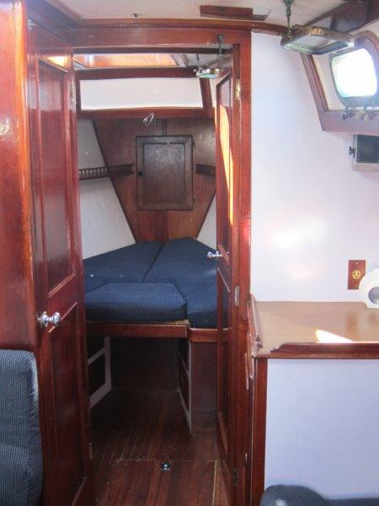
Saloon – looking fwd to V-berth and fwd head.
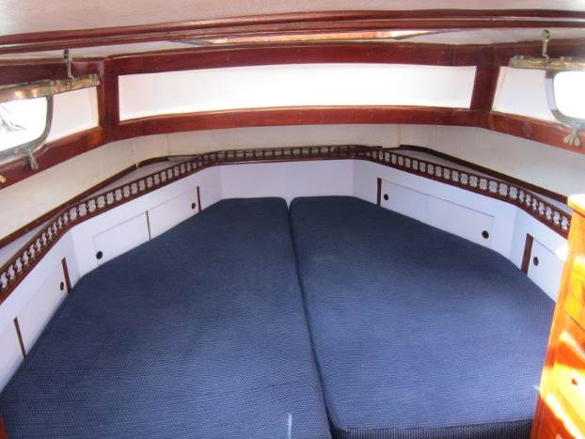
Aft bunk – looking aft

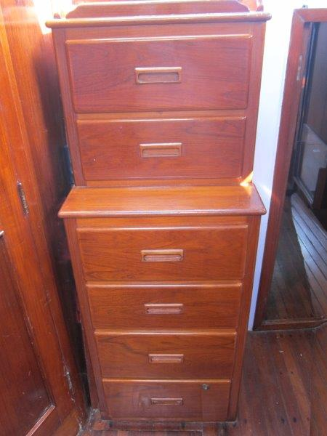
Aft bunk – looking fwd
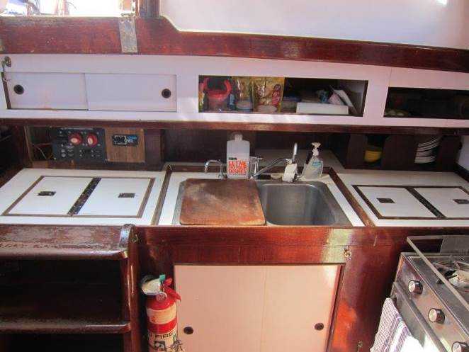
Galley – looking aft. Three burner cooktop (oven broken), H&C pressure water. Drinking water, salt water. 12v ASU fridge.
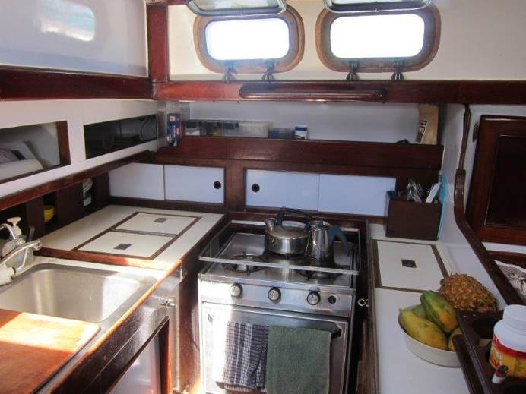
Galley – looking to port.
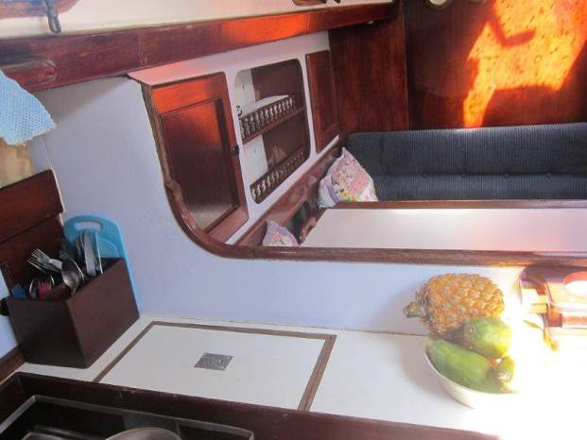
Galley – looking fwd
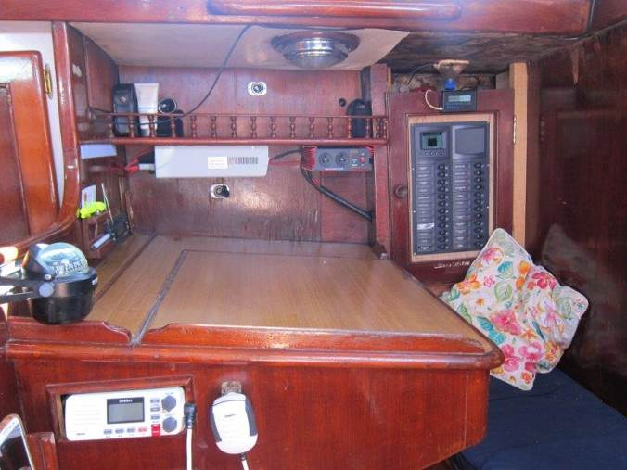
Nav table - looking to stb.

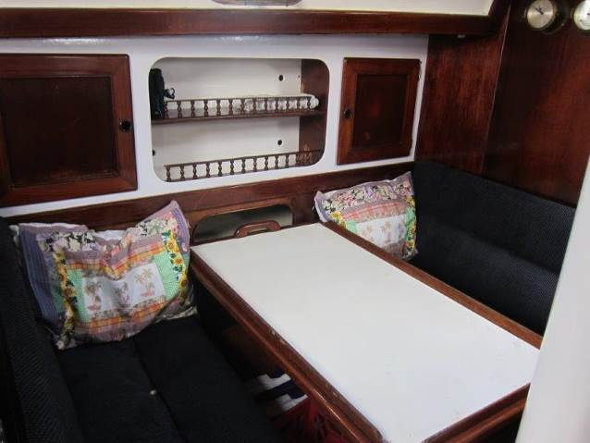
Saloon – looking to port.

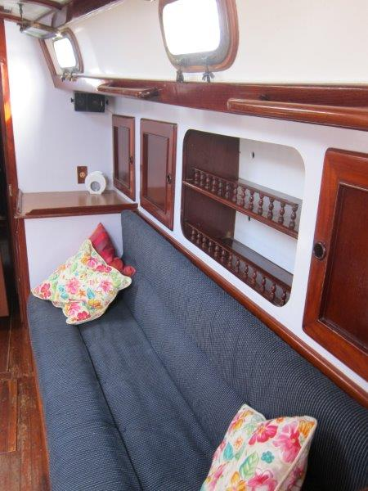
Saloon – looking fwd and to stb

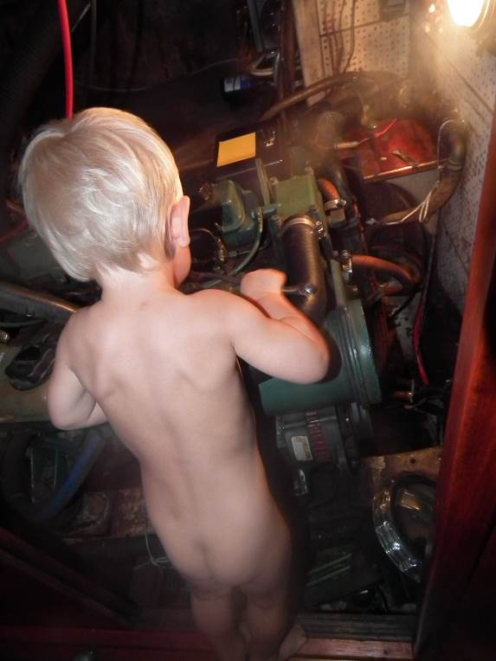
Engineroom with assistant chief mechanic on the tools.
T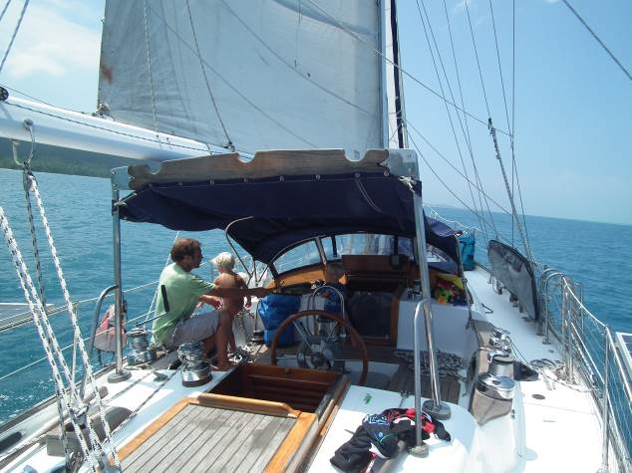
Aft cabintop and cockpit.
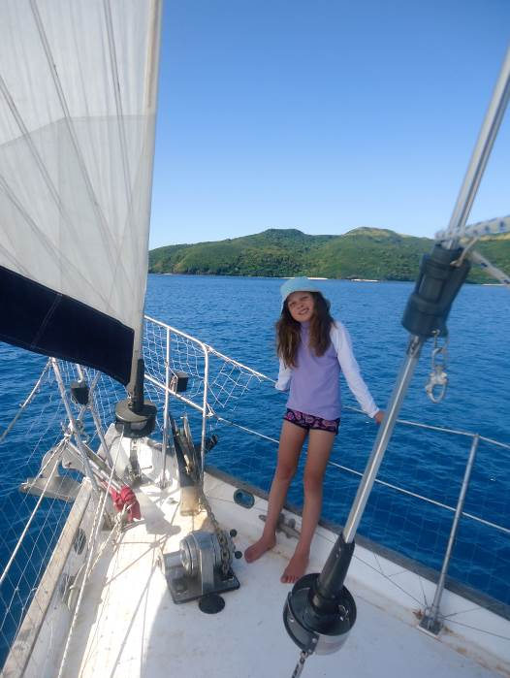
Foredeck – sailing Nth, westside of Naviti

