Vessel Name | Syrinx
Type | Formosa 46
Year of Manufacture | 1978
Hull Number | n/a
Current Location | Virginia Beach, VA USA
Selling Price | US$ 119,000
Owner | Tom Evans
Contact (email) | tevans2@aol.com
Telephone | +1 (757) 971 1037

s/v Syrinx
History
Syrinx is a 45’ Formosa 46 which is an extremely popular center cockpit cruising boat. It combines outstanding sailing performance with a strong, sea kindly, and safe vessel. Its hull is built with solid GRP and is immensely strong.
We have owned and cruised Syrinx for the past 12 years (since 2002). During that time we have done the following upgrades and maintenance:
- Bulwarks were cleaned out and filled with West System epoxy and filler.
- New cap rails were built and installed
- Stainless backing plates were fitted to all cleats, pulpit bases, pushpit bases and attachment points for foresails
- Wi have all new cushions throughout the boat
- Custom built deck boxes are curved to match the curves of stern.
  - one houses two 30lb propane bottles
  - the other is storage.
- New pulpit (2003)
- New pushpit and davits
- New Main and Jib (2003)
- New asymmetrical (2006)
- Hull soda blasted from deck to keel and new barrier coat applied ((2006)
- Rudder rebuilt (2007)
- New frame for bimini and dodger (2010) and new bimini and dodger
- Mid ship deck cleats removed from deck and mounted to bulwarks
- Chain plates attached to hull (2012)
- Cabin top rebuild (2010)
- All ports removed, spaces cleaned and filled with west epoxy and filler. (except for aft cabin)
- Glass in all portlights was replaced and new gaskets installed (2005)
- New refrigerator box built in (2008)
- New refrigeration compressor (2010)
- Lofrans Tigres horizonal Windlass rebuilt (2011)
- Rewired most of 12 volt systems
- DC electrical panel new as of 2005
Equipment List
SAILS
- Main
- Jibs
- Staysail

TANKAGE

- 142 gals fresh water in stainless tanks water manifold in engine room
- 120 gals fuel in two stainless tanks

ENGINE
- Ford Lehman 80 hp. Engine approximately 8500 hours

DINGHY
- 12 foot
- 15 hp. Outboard
- Outboard mounting pad on pushpit

EQUIPMENT ON DECK
- WINCHES
  - Primary winches mounted on cockpit coaming: Lewmar 56 self-tailing
  - Secondary winches mounted on cockpit coaming: Lewmar 40 self-tailing
  - Aft cabin top winch: Baron 5
  - Main halyard winch on main mast: Anderson 40ST 2 speed self-tailing
  - Secondary halyard winch: Lewmar 40 self-tailing
  - Reefing winch on boom: Barlow 15
- ANCHORING SYSTEM
  - Lofrans Tigres windlass (horizontal gypsy and rope drum)
  - 350 feet 3/8 chain rode attached to 48 lb (20kg) Bruce anchor
  - 250 feet 3-strand anchor line
  - 40 lb. Danforth anchor mounted on pushpit
- Four winds wind generator on stainless pole
- Typical cruising gear is included: charts, safety equipment, lines, fenders, grill, lunch hook, spares, etc.

EQUIPMENT BELOWDECKS

- PUMPS
  - Flojet automatic bilge pump 9 gph
  - Automatic bilge pump Rule 2000
  - Manual bilge pump: Gusher Whale pump mounted in cockpit
  - Flojet pressure activated fresh water pump
  - Manual foot pumps in galley for both fresh and salt water
  - Flojet pressure activated wash down forward
- GALLEY
  - Force 10 3-burner stove and oven with broiler (broiler new in 2013)
  - Corian counter tops and salon table
- RADIOS
  - Icom SSB tuner in aft cabin
  - VHF
  - SSB
- STEERING
  - Octopus hydraulic auto pilot controlled by Nexus system
  - Nexus Steering
  - GPS linked to steering
  - CPT auto pilot back up
- NAVIGATION
  - Furuno radar with repeater in cockpit
  - GPS

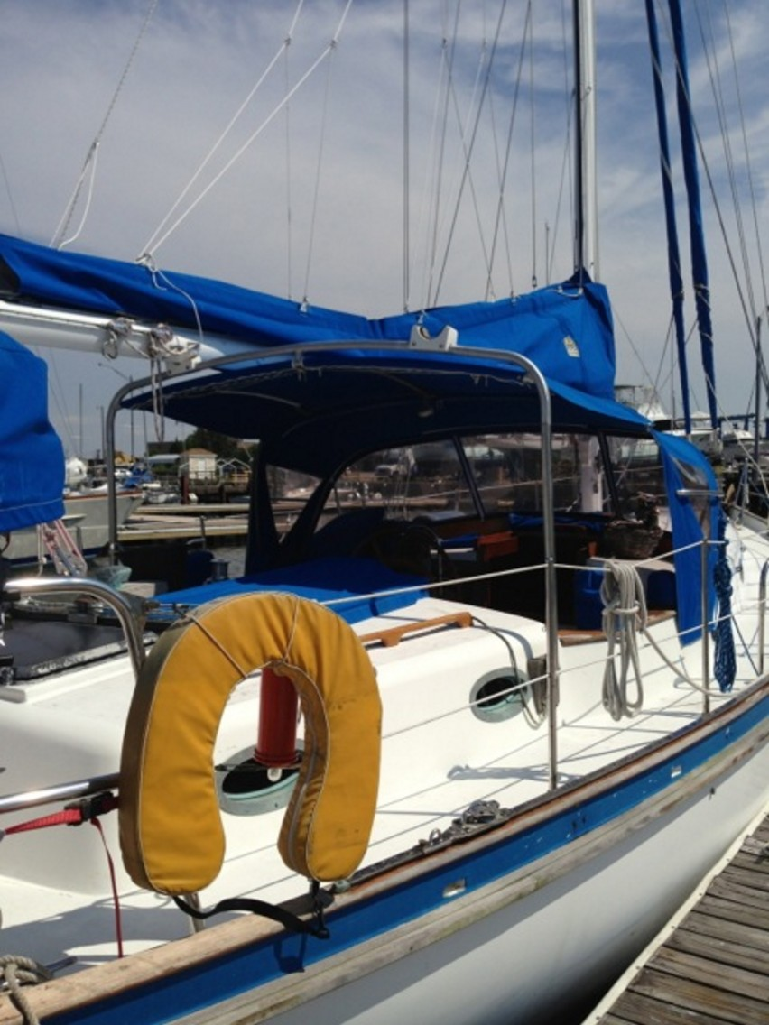
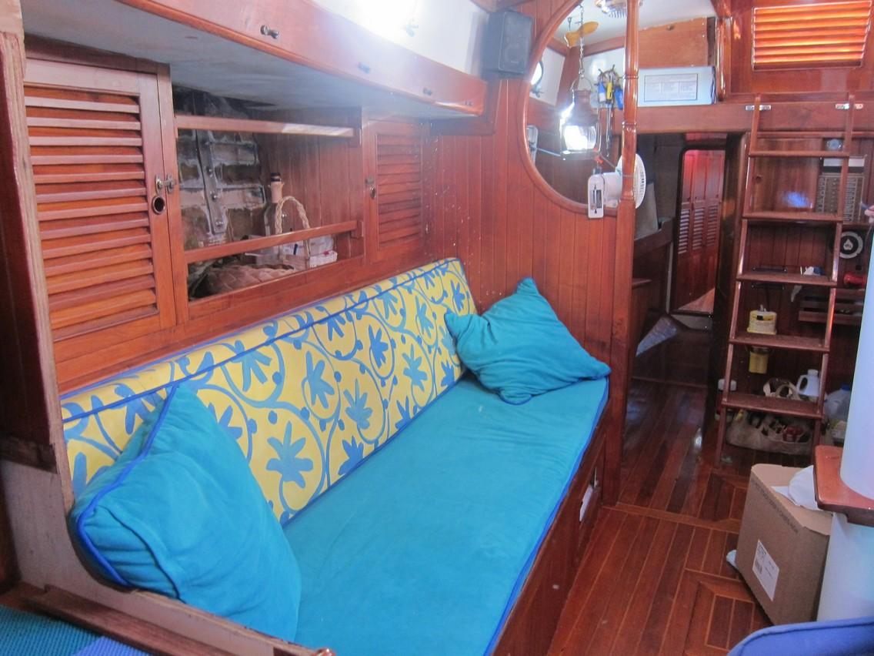
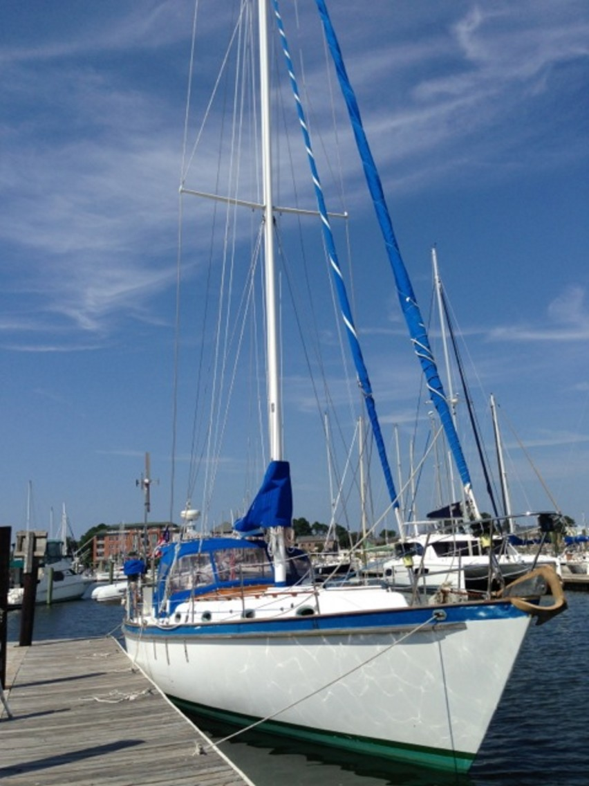
Syrinx Photos
