FORMOSA 46 BACKSTAY PLATE AND CHAIN PLATES

Ralph Ferges – Sola Gratia F46 San Diego, CA. USA

rferges@palomar.edu

I decided to include commentary along with the photos as some of them were not self evident.

First let me say that I am in the process of a major – gut it and start over – refit so I have or will have lots of other photos of buried parts as they are exposed. As it stands the galley, saloon and aft cabin are gutted and the floors are out to the hull so tanks can go back in.
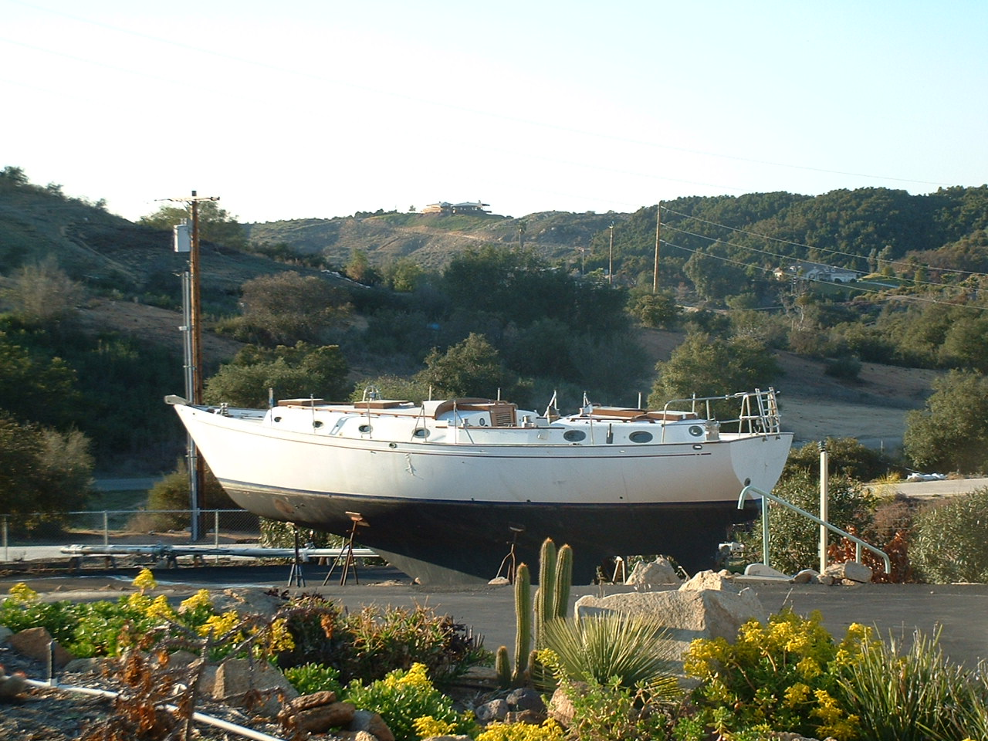

The photos of the backstay show a vertical brace that runs from under the deck, between the 2 stainless steel plates. All of this is covered with the centerline box at the aft of the cabin.
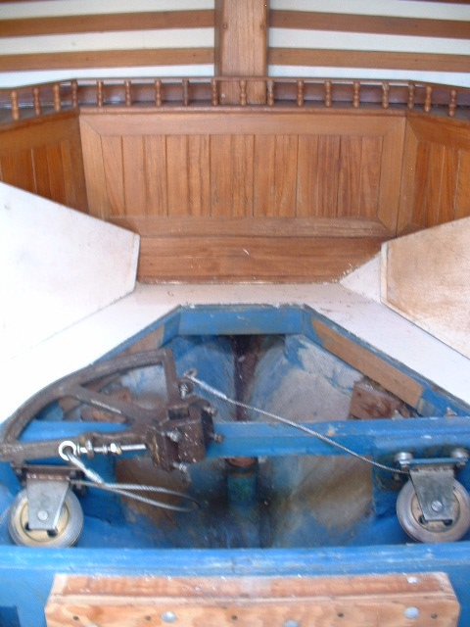
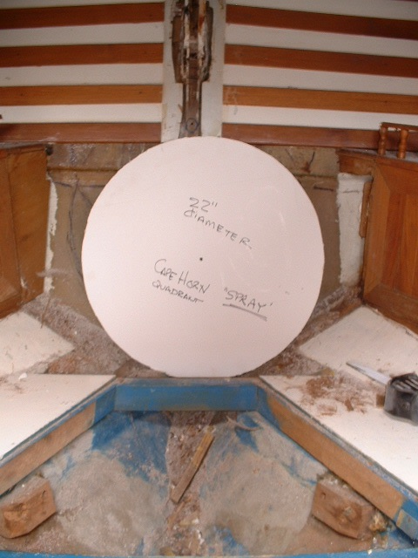
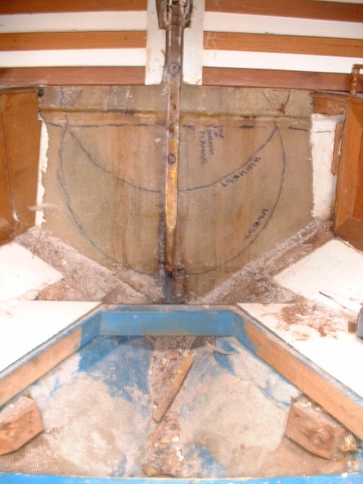

This brace is made of mahogany about 1” thick and is bonded to the transom and deck with lots of cloth and resin. It has been drilled for two bolts – wood left unsealed – to match the stays. The stay is inserted from the outside of the transom angled up towards the deck.
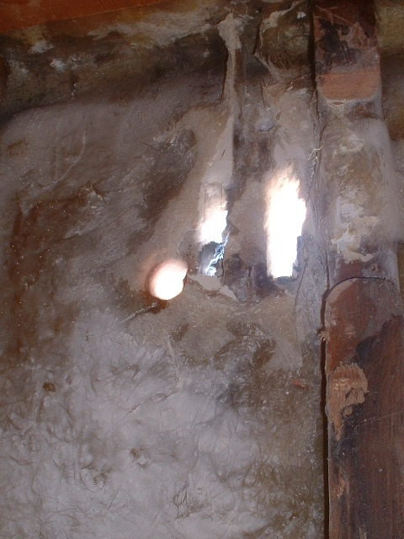

It had a large amount resin putty between the stays and the holes/slots cut into transom and some squished into the area covered by the circular external plate.

Large amounts of thickened resin – looks a lot like marine tex white – was added between the stay plates and the vertical mahogany brace and then two through bolts were inserted.

Then all of this was covered with many layers of mat, cloth and resin from the underside of the deck to the very lower portion of the vertical mahogany centerline brace.

The end result of all this is that the backstay stainless steel is imbedded into a water tight cup along with the mahogany brace. Over time water ingress at the backstays that are above the aft deck has no place to drain. Great environment for rot and SS corrosion. I gutted it all back to the hull laminates and have started over.

Another major concern of mine was the metal parts themselves and from the photos you can see some corrosion of the stays but more importantly to me is the attachment of the stays to the circular plate

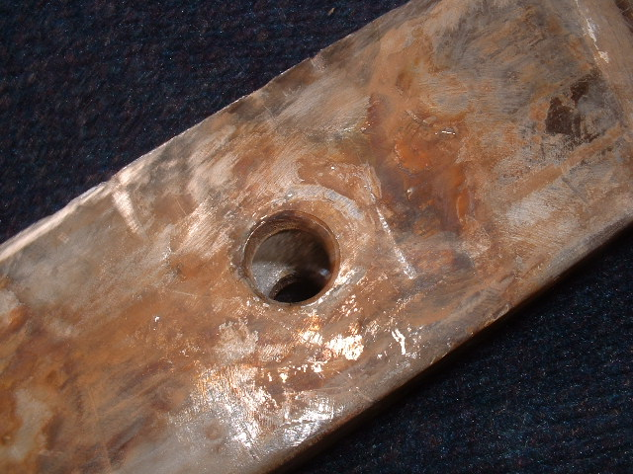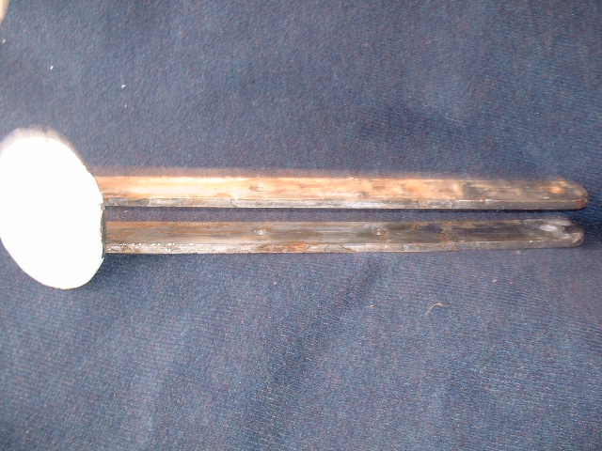

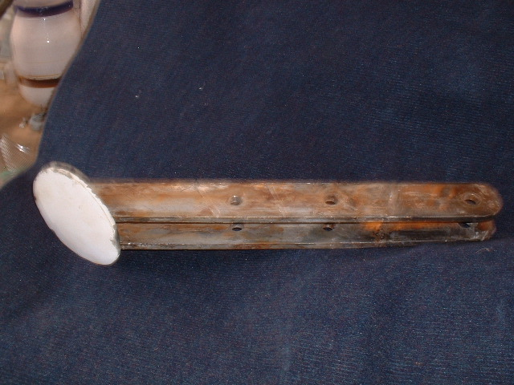

IMHO, the welding is inadequate as the welds (TIG) are only on the outside portion of the plate/stay junction, not on the inside, are very small or thin and do not look to have penetrated much at all.
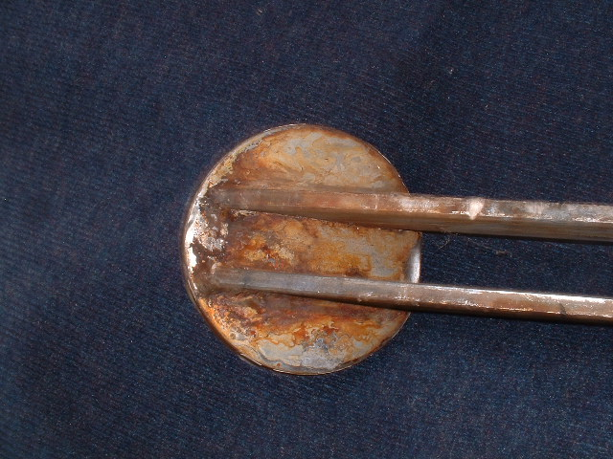

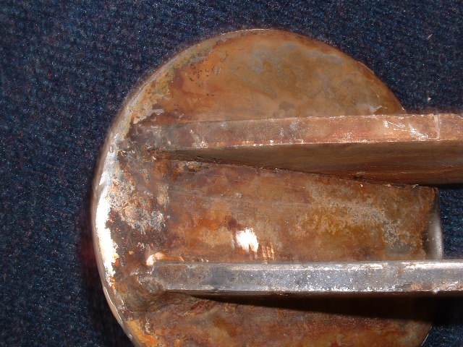

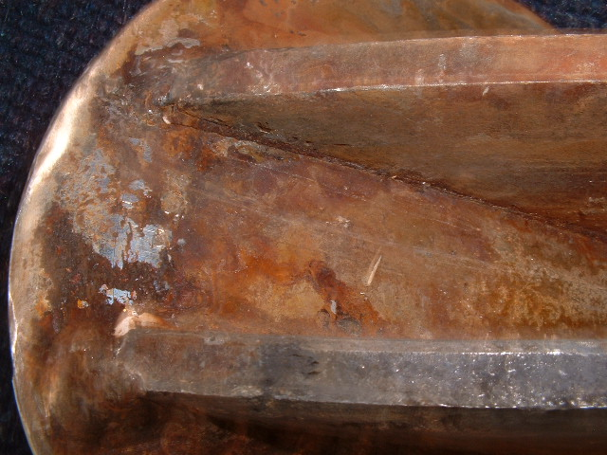

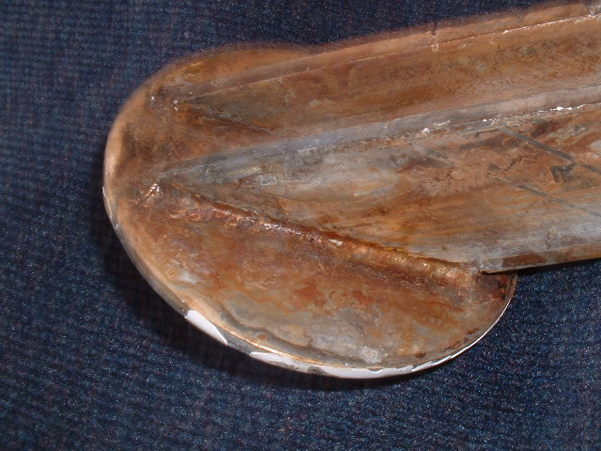

While I like the idea of using the external circle to carry some load due to all the rot in the rest of the system mine was responsible for all the load. I don’t think the welds would take it as they looked like fine light duty welds you might see on a bimini or dodger frame. They need to be structural welds not just cosmetic welds.

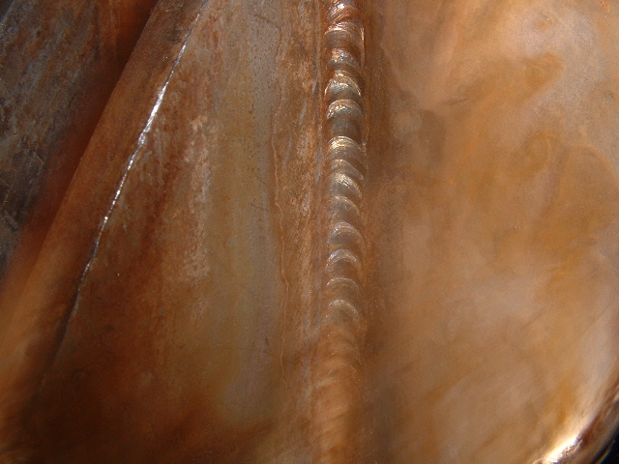

I hopes this helps those of you that just love these old boats. They are great sailing cruising boats.

Ralph

