Sailing History of Jeff Stander

My birthplace was New York, New York, but from the time I was a baby I grew up in Los Angeles, mostly in Hollywood and the San Fernando Valley. I have sailed (on and off) most of my life. My mother claims responsibility, stating that she took me sailing in Mission Bay when I was 8 and that I insisted on doing it solo. I am not too certain of that story, but I did sail whenever I could. At the University of California Berkeley I became very active in the UCYC and truly learned sailing on San Francisco Bay in UCYC small boats and by crewing on larger boats on weekend races. \

I found out that I like sailing better than racing. There are other and better ways to win besides coming in first. In 1969, I was invited to spend three weeks aboard Senta, a beautiful 52’ wooden cutter, sailing from Trinidad to Martinique, which was my first time aboard a cruising boat.

There was a long hiatus after that. I moved to Oregon for graduate school, then to Vancouver, Canada for more graduate school, then back to Oregon where I spent about 13 years as a student, college professor, farmer, and computer business owner. In 1987 I got a job as Computer Manager for the South Pacific Commission headquartered in Nouméa, New Caledonia – a French colonial island in the Coral Sea. I traveled all over the South Pacific during that time and met many cruisers. I lived at that time in a small villa and I had a car and a washing machine, precious items to world cruisers, and these helped me to meet and make many cruising friends. I did a lot of sailing near New Caledonia and I also made several ocean passages on other people’s boats: Fiji to New Caledonia, New Cal to Vanuatu (as far as Efate), New Caledonie to Bundaberg, Australia. I said to myself “this is what I want to do”.

During my “Nouméa Days” I also learned to SCUBA dive and had many wonderful dives in Guadalcanal, Tulagi, Papua New Guinea, Fiji, and Micronesia. I knew that a dive compressor aboard Beatrix was a must.

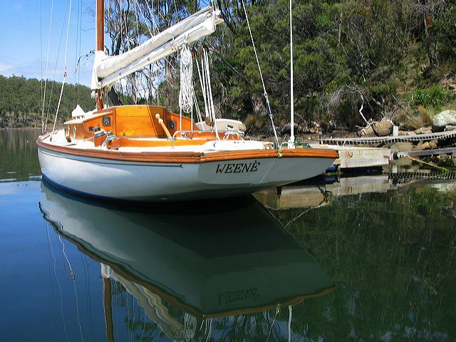
In 1992 I went to work for the Australian government research organization CSIRO in Hobart, Tasmania. Hobart is the finish point for the famous and difficult Sydney-to-Hobart race. My job in Hobart was to build the world’s largest tuna fish database. I lived and sailed there for 2½ years.

For 18 months I co-owned Weené, a fast and fun 1910 36’ wooden Edwardian daysailer (fin-keeled, fractional rig, no lifelines, enormous bowsprit!), which I “cruised” up and down the d’Entrecastaux Channel and up the East coast of Tasmania. Many happy days were spent on that beautiful boat.

After that I realized my dream of being a live-aboard cruiser. In Townsville, Queensland, I bought a 35’ Adams steel center-cockpit cutter. I sailed around the Whitsunday Islands for a few days and then started to sail back to Tasmania. Unfortunately the engine packed it in both in Bundaberg, and then in Mooloolaba, and it needed to be rebuilt. I had to fly back to Tassie to return to work. Friends of mine sailed my boat to just south of Sydney and I was able to sail it from there to Hobart. Shortly after that (1995), I decided to move to Melbourne to be a consultant. At that time I was granted Permanent Resident status in Australia. I sailed from Hobart to Melbourne where I lived tied up to the old North Wharf. My good weather karma was working well and Bass Straight was dead calm.

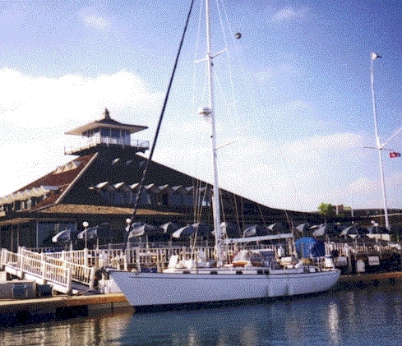
In 1997 I was back in Oregon and met an old flame and her 9-year old daughter Sarah. We decided to get married, sell my boat in Oz, buy a new boat, start a business, make lots of money, and go cruising. We achieved some of those objectives and it was wonderful for a while. We did buy Beatrix, a Kelly-Peterson 44 center-cockpit cruising. Here she is on the first day of ownership, tied up to the guest dock at the San Diego Yacht Club in 1997. Our plan was to sail her up to Seattle, but the sails were too old to go to weather, and we had to put her on a truck. We chose Seattle because it was such a great place for a boat, and for Information Technology.

I had a concept for a business to bring Australian Oracle practitioners to fill the insatiable (at the time) need in the USA for IT professionals. This led to the creation of ANZUS Technology International, an IT consulting company in Seattle, which was (and is) moderately successful.

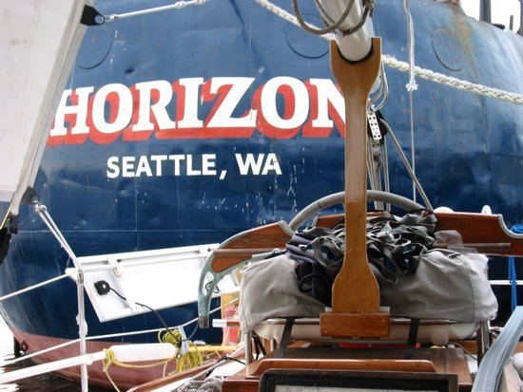
The three of us lived on the boat in Lake Union with a wonderful view of downtown Seattle. When we moved to a new shipyard, we could see “all the way to the Horizon”. I had a workshop there and the company office was in the same shipyard. It was a perfect site for business and boat-refitting. I loved the life. We had a happy family for a long time as liveaboards. Sarah (now 19) and I are still very close. But things did not work out with my wife. When we broke up in 2004 she agreed I would keep the boat and the sailing dream; she wanted to run the business. So, except for not wanting to solo sail, which I feel is both dangerous and not as much fun, everything is as it should be. I still have the boat, the dream, and a modest cruising kitty. Time to go!

A lot of work has been done on Beatrix and she is well-equipped, with new sails and almost all her other running and standing gear replaced as well. It’s a boat, so there is always maintenance and repair. There are things yet to do – the decks look bad, the brightwork needs re-varnishing and the upholstery is awful (FLASH. New upholstery was just finished) – but the mechanical and sailing equipment is tiptop and this class of boat is one of the finest performance cruisers ever built.

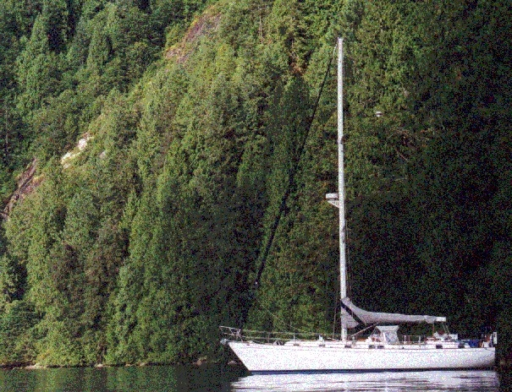
The KP44 has become a “cult boat” among cruisers. It is well-known and buyers actively seek these vessels. At 27-31 years old, these boats are actually increasing in value. In 1997 I re-started the Peterson Cutter Owner’s Group as a mailing list for owners of the KP44, KP46, Spindrift 46 and Formosa 46 vessels. ( Formosa 46 is an unauthorized copy of the KP44). The mailing list is now maintained by Yahoo Groups as the Peterson Cutter Yahoo Group and I built and currently maintain the KP44 website. Because of this I have become the (possibly undeserved) “guru” of the KP44.

During the years in Seattle my family and I cruised around Puget Sound whenever we could. In my humble opinion Puget Sound is the best place to have a cruising boat on the West Coast of the USA. The sailing is not always good, due to lack of wind in the summertime, but there are beautiful safe anchorages everywhere all the way to Alaska.

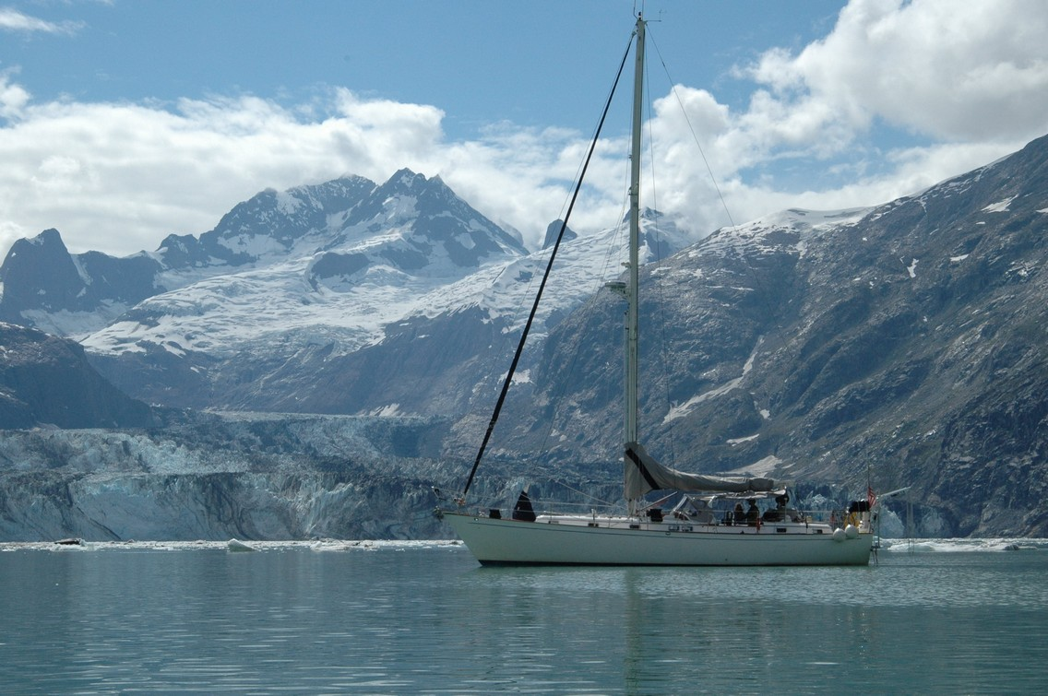
In 2005, single again, I sailed to Glacier Bay and Juneau, Alaska, with good friends aboard. It was so fabulous I made a second visit to Glacier Bay on the way back to Seattle, sailing down to Sitka and transiting the Pacific side of Chicagof and Barfanov Islands. It was magical. Photos of the trip are all on the Beatrix website.

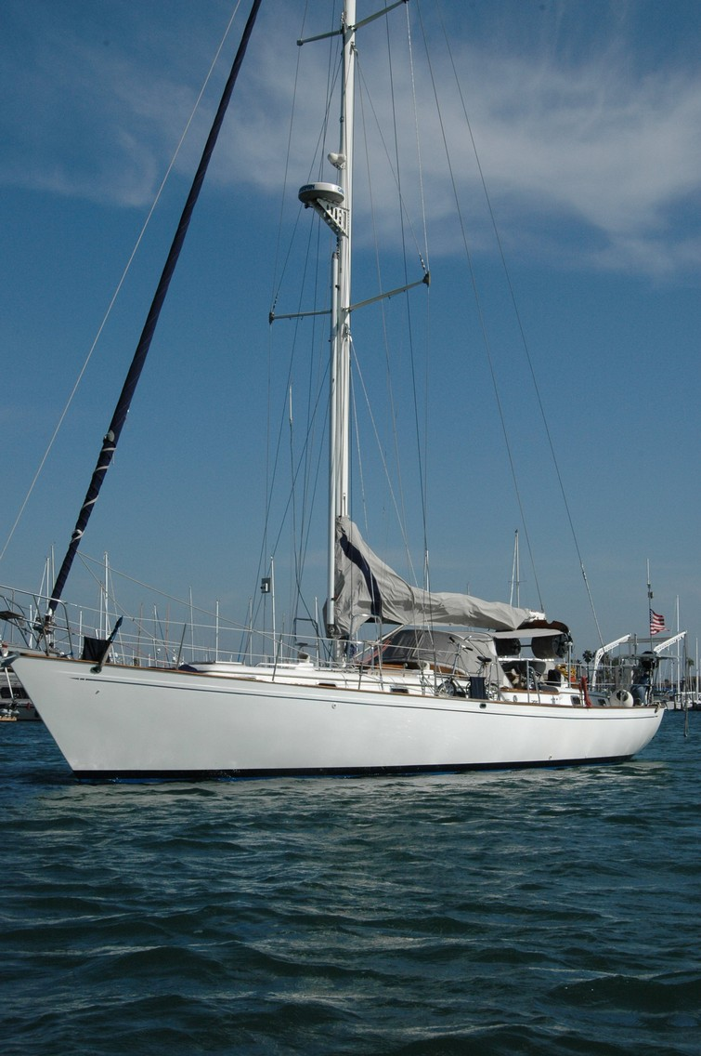

In Sept, 2006 I left Washington State for good to start my voyage back to Australia. I sailed Beatrix down the entire West coast of the USA to San Diego and Ensenada, Mexico. It was a great voyage with good weather and good friends. Weather karma held again and Point Conception was very calm. I was planning to leave for extended cruising that year but decided to delay until Jan 2008 in order to more fully prepare both myself and boat. As John Lennon said: “Life is what happens to you when you are busy making other plans”.

In 2008 we sailed to the Marquesas, Tahiti, and NZ or Australia, departing May 2008 and arriving in Bundaberg, Queensland on 31 Dec 2008. We were very happy to be offshore and now are thinking about the next voyage.

Jeff Stander
Mooloolaba, Queensland, Australia
28 July 2026
www.svbeatrix.com
skipper@svbeatrix.com

