STALKING THE BLUEFIN TUNA

A PERSONAL JOURNAL - Ten Days on a Japanese Longliner

J. M. Stander
CSIRO Marine Laboratories
Hobart, Tasmania

Sun Jul 10 02:58:19 SYD 1994

I have been aboard the Australian Maritime College's training vessel Bluefin since Thursday. I am to be put onto a Japanese longliner fishing Tasmanian waters for Southern Bluefin Tuna. My job is to place yellow barbed plastic tags in the backs of selected fish so that, on recapture, they may contribute to our tuna fish lore -- where they travel to, how fast can they do it, and how large they grow in that time. This is very unlike the last tagging work I did between Micronesia and New Guinea. No twilights on the foredeck sipping SP beer. This is the Southern Ocean south of Tasmania, in winter, and it is cold and windy.

The Bluefin, known without affection as the "Spew-fin", is the rocking-est rolling-est boat I have ever been on, certainly for its size of 35.5 meters (about 125 feet). I haven't exactly been seasick, but then I've hardly gotten out of bed, either. It has been designed with an overly wide beam for its length and a lot of heavy ballast, so it pitches and rolls alarmingly, and this is in relatively good weather.

We left the AMC at Beauty Point (a harbor in Northern Tasmania) on Thursday morning. I thought I would be dropped off right away, but the logistics of weather, speed, and distance dictated that the other observers (remarkably all women), who were to board vessels in the south, be delivered while we had the opportunity. This has almost been done -- one more to go -- and then we will head back up around the eastern edge of Tasmania where the seas will be flatter, to find a boat for me and Donna, our last observer to be placed.

When I agreed to go on this trip I hadn't envisioned spending three days just to get there. Bored and queasy, I am a bit nervous about what is to come aboard the Japanese boat -- 10 days or so with no one to talk to and 12 hours a day on a cold, wet deck covered in fish blood and slime. I guess I'll just have to find out. Not being comfortable here in the Bluefin has sapped my energy and enthusiasm for the next stage.

The women observers surprised me. Not that I am being sexist, I just didn't expect any women would want to do this? But they do want to and they keep coming back. None of them are Tugboat Annies. The three observers are a different lot, all of them. Sam is very young, quiet and competent. Kirstie is tiny and friendly. Donna is "rough as guts" as they say in Ozzie, always swearing and making crude jokes.

So far we have picked up three observers (all men) who have been out for a while. The trips last up to several weeks, usually only about 10-12 days on a given boat. They can ask their captain to transfer them from one fishing boat to another with an inflatable raft or dinghy. On Bluefin they use a Zodiac rubber boat with a hard keel that is winched up the trawl ramp in the stern onto two special padded rails. Leaving the Bluefin the rubber boat just slides down the ramp. It looks a bit hairy and I shall be scared when my time comes, but everybody seems to be OK. I'll have on my survival suit and EVERYTHING WILL BE JUST FINE.
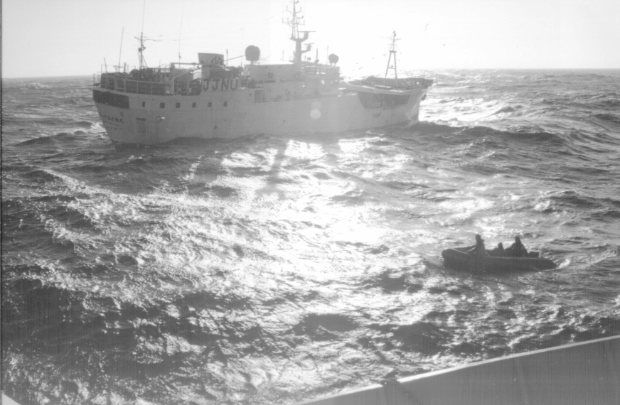

I don't feel normal out here. I don't feel exactly all right. The boat motion is fierce at times. I am doing nothing but reading and sleeping and eating way too much. I had looked forward to rice and noodles for 2 weeks and this will surely come tomorrow. I'm too queasy to stuff myself today, just enough food in my stomach to help me feel better. When I get very nauseous I curl up in the foetal position on my bunk and it passes. I only had one bad attack while vacuuming my cabin with my head down.

21:18

We've dropped off Kirstie and Sam. Bluefin sailed as far south as 45 degrees into the Southern Ocean, the infamous roaring forties, taking advantage of this good weather. Now that we are heading east the rollers and wind are from behind and the boat motion is much improved. The Jap boats, the others say, are much more stable -- better sea boats. I am told my boat is to be the Koryo Maru 58. We will reach her on or before noon tomorrow, Saturday. With the 10 tonnes or so left in her quota, it might be 7 to 10 days before she is through. We will sail into Hobart then, so I should not be seeing Bluefin again.
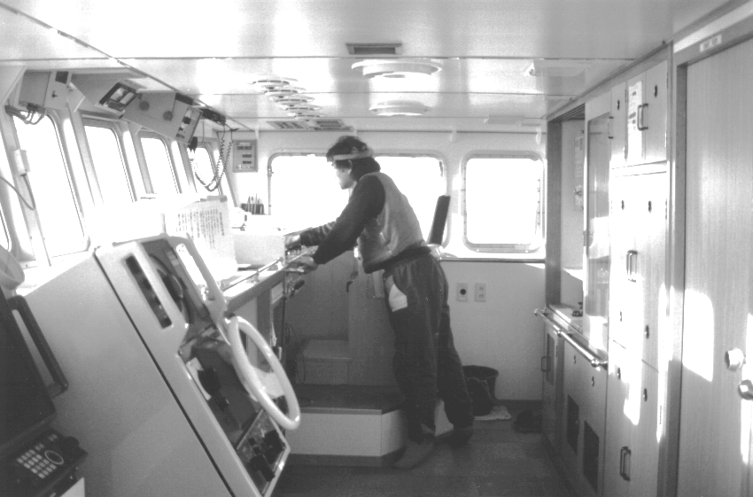
The Fishing Master at work

I spent a bit of time talking to Nigel Brothers, who came aboard today. Nigel is particularly interested in the seabird bycatch and is concerned about developing methods to reduce this. A large long-haired man with a full beard, he seems friendly and outgoing. He says the Jap boats will feed me well (rice and noodles?). He likes being on them, and has done 2 of the 3-month RTMP observer cruises. The RTMP cruises are the ones I built the data entry system for.

Mon Jul 11 00:17:10 SYD 1994

A change of plans. I have arrived aboard Kaigata Maru 86. Lucky me! This is a new and very clean ship, one of the newest and biggest in the fleet at 56 meters of overall length. I even have my own small cabin with a narrow bunk and tatami mats to sleep on. The day is sunny and shirtsleeves warm and the seas are flat and calm. The ship lies hove to off of Maria Island on the east coast of Tasmania. I think it is about two hours to haul time, when the longline will be brought in. Nigel Brothers, Ian Peel (Peely) and Porky on Bluefin made me a fish net out of a crayfish ring so I can try to catch the smaller bluefin without too much damage so they can be tagged and released. Later on I will discover that this net is too shallow and the tuna too heavy for this to be of any use.

Lunch was miso soup, rice, and grilled salmon with daikon and grated cabbage. I have been given my private chopsticks and a drawer in the mess room in which to keep them. The chopsticks are kept in a special plastic box with a sliding lid. Everybody's box is a different color and design. Mine is blue with little dots and the label "Fruit Shower". There is a communal shower and a deep Japanese bath. I have met the fishing master Toru Maekawa. The captain is Kiyoshige Sakai. They appear very young to me but I know it takes many years to become a fishing master. We are communicating with the very few words of English that they know and sign language. The captain is not the head honcho on board -- as the success or failure depends on the fishing, the fishing master is in charge of everything while on the fishing grounds. He also has the biggest cabin and makes the most money. The captain takes over when the boat is not fishing, i.e when it is making port or during passages.

Tue Jul 12 23:35:42 SYD 1994

I've now been through two hauls of the longline. The hauls have been starting at 12:30 PM and take twelve hours to complete if nothing goes wrong. The idea of the longline is staggering. A hundred miles of 1/4" tekron three-ply line, called the mainline, is strung out on the sea surface. It may be in a straight line, a large "U" or some other pattern. Spaced evenly along this line are 450 plastic buoys. In older times they would have been those lovely green glass netted balls that you see as part of the decor of seafood restaurants. Each buoy delineates a "basket" with six hook-terminated branch lines clipped at regular intervals to the mainline. Every 40 baskets is a radio buoy to help locate the line in case of breaks. Picture the plastic buoys on the surface supporting the mainline about 15 meters down, with the weighted hooks dangling below that. 450 baskets times 6 hooks per basket makes 2700 baited hooks in the water. Bait is frozen squid and mackerel.
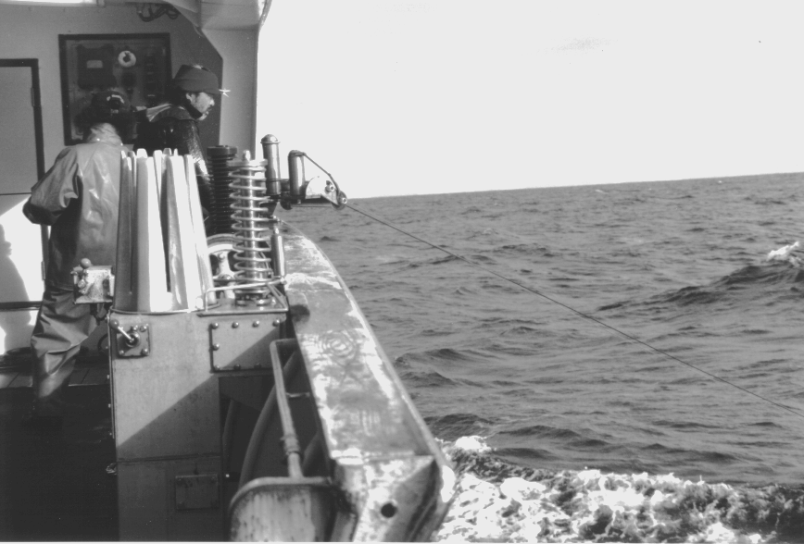
Hauling in the mainline.

This entire collection of lines, hooks, and buoys is assembled, deployed, retrieved and disassembled daily. About 12 men work on the well deck forward of the bridge during the haul and 4 or 5 are required for setting. Setting is easy but monotonous. The coiled branch lines are set on a conveyer belt. The mainline comes out of a line thrower on the stern at about 7 meters/second while the boat steams at 10 knots. The line is fed from four large rectangular tubs on the upper deck where it has been carefully flaked down by machine.

One man is tending the line thrower, another baiting the hooks. A third grabs the mainline when a buzzer sounds and clips on a baited branch line. He tosses it to the side so it streams out without fouling the mainline. Every 6 hooks the buzzer sounds a different tone and a buoy is clipped on. The hooks are very clever things looking like large safety pins. A single squeeze opens them and on release the grip the mainline tightly so they don't slip. It takes about 5 hours to set 100 miles of line.

Hauling is another matter. The ship steams parallel to the line of buoys. The mainline comes aboard on the starboard side at a rate that matches the forward speed of the ship, about six or seven knots. It passes over a set of stainless steel rollers and into a special winding machine that spits it into coils on a conveyer belt. Every so often a fisherman tending the line pushes the button that feeds the line at high speed through PVC plastic pipes to the stern of the ship, and back into the tubs. The line is wound in so fast that it appears alive as it jumps and skitters around like a snake, whipping out from the coils on the belt.
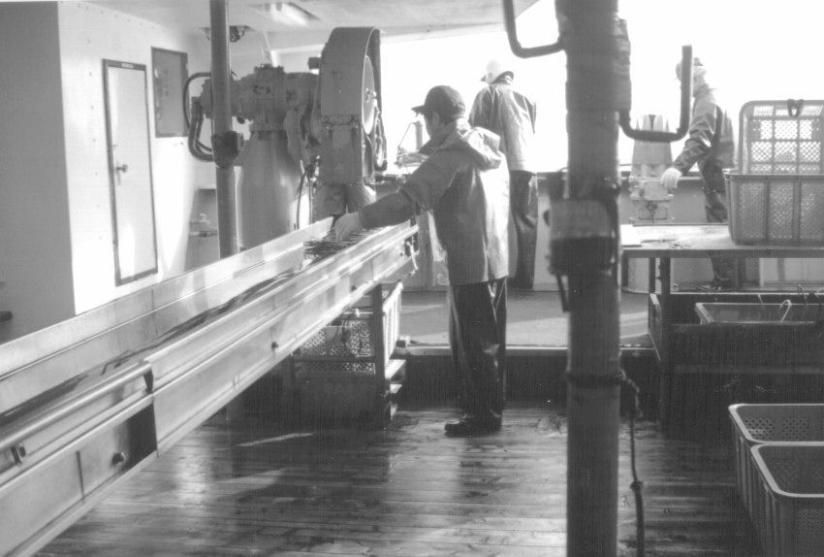
Mainline conveyer belt

As the mainline comes in, bending from its parallel track, the branch lines stand out from it. The fisherman standing at the feed roller can, if he is fast, grab the clip and neatly unconnect it from the mainline. If no fish is hooked he drops the clip onto a machine nearby which coils it neatly -- first the rope part, then the clear monofilament nylon leader with its large barbed hook. The last few meters are coiled by hand.

If there is a fish hooked, the fisherman passes the line over the heads of those on the rail and to an opening in the rail. The line is clipped to a safety rope and the fish is hauled in. Gaffs are made ready. As many men as necessary haul in the fish by hand. A really big fish might call for the large gaff hook attached to a winch. This happened twice, yesterday.

They are looking for the big sleek Southern Bluefin Tuna which bring the top prices on the Tokyo markets. They want the "Jumbo" tuna that weigh in at 100 kilos or more, but we are catching a lot of smaller 20 to 25 kg fish.

Watching the men at work is fascinating. It is like a dance. The ship bores through the night, waves streaking past. The line thrums in over the rollers and winch drums. With a wave of an arm and a pirouette a line is snatched and while the first fisherman slides over to the coiling machine another takes his place. There is no fixed job that I can tell. There is always time out for a smoke or cup of tea. They drop in or out at will. Some are mending the lines which were cut off sharks or snarled. Others tend the mainline conveyer belt. If a fish has been caught one or two men will be cleaning and processing it to go in the freezer. All those jobs are rotated over the hours it takes to retrieve the line.
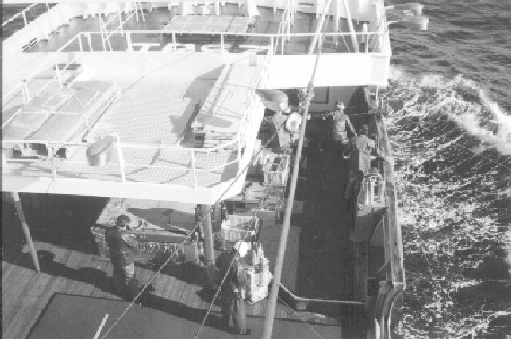
Looking down on the haul deck

Sometimes the cook and radio operator are there, and the engineers. Everybody takes works on deck except the Fishing Master.

The men seem to clown around and laugh a lot, playing the Japanese equivalent of grabass -- using my useless tuna net to snare another fisherman, giving each other what look like affectionate embraces. I can't tell if these are jokes or not. They are gone for 11 months of the year. Many are married. I am reminded of the long voyages old-time sailors used to make, years and years long. These men make good money, but is this a life?

They ask me "Wife?" "Baby?". No, I say, no wife no baby, me happy man (ha ha). What a strange life this is. This is my fourth day. I could happily go home now, but it gets easier and I expect after a while will begin to seem normal. It's very good that the ship itself is one of the nice ones.

The cleanliness of this ship is amazing. The color is white with pale green on the bulkheads. The ship itself is completely neat and clean. Everything is wiped down daily. Blood and guts are continually rinsed over the side. Tools are neatly laid out. Bins are ready for plastic scraps. Everything has a purpose -- the design perfected long ago. I thought I might lose weight on the boat. At least none of the food is fattening but there IS a lot of it. Lunch is at 11:00 and two meals are served at 4 and 8 hours into the 12-hour haul. The mess room has small cupboards and drawers for the crew to keep their chopsticks, candy, smokes, etc.

Everyone has been very friendly but the total language barrier is difficult. I haven't yet figured out the shoe thing. You can't wear outside shoes or boots inside the ship, but the mess room, apparently, is part of the outside, except the fishy foul weather gear is hung up in the alleyway. I tried to leave some shoes in the alleyway but was told (in sign language) that this isn't correct. However, there are dozens of shoes on the floor of the mess room, left outside when entering the living space or to be worn into the living space? I'm not sure. The Fishing Master also told me to keep my boots somewhere else than outside the wheelhouse door (unless its for a moment). Bare feet are not allowed, I think. As I said, I don't have the hang of it. I'm just trying not to offend anyone.

Twelve hours on deck is a long time. I've been doing the whole set except for the last few hundred hooks.

Finished the first haul observation. I did the entire haul except for the last 240 hooks. There is a lot of helpfulness and friendliness which makes my job of tallying weights and numbers much easier. When a tuna is landed I must record exact position, length, sex, whole weight, dressed weight (after guts and gills and tails and fins are removed) and take stomach samples and female gonads.

The biggest fish we landed so far was 150 kg. These are like the huge ones hauled in during the heyday of the fishery, and will be worth thousands back home in Japan. "Jumbo, jumbo" cry the crew. If the fish is alive on landing it is pithed in the brain with a spike to kill it. Sometimes a little triangular hole is cut in the forehead and a stainless steel wire run down the spinal cord. This causes a last spasm of tail slaps. A tiny strategic poke in the side with the carbon steel fish knife drains the blood. The heart keeps pumping long after the brain is dead and the flesh is emptied of blood. If the fish is a large one the heart is cut out when the fish is gutted and set on the bench where it continues beating for several mintues. It is a delicacy, I'm told. When the fins are trimmed, the tail cut off, the gill plates and guts removed, this sleek speedy fish looks like the fuselage of a wingless airplane abandoned in the desert. I am beginning to hate the part with the wire and walking around in blood.

Dressing the fish is done by all the fishermen in turn, although some seem more experienced than others and are obviously more careful and neat. A length of longline is poked through a hole in the tail and tied. This makes a convenient handle to sling the fish by. Colored plastic streamers are tied to the line and through the gill opening to indicate the place of capture.

I stand there with my ziploc bag ready for the stomach, which will be frozen and taken back to the CSIRO marine lab for contents analysis. If the tuna is female and large, the gonads are also saved.

It is strange how the time passes. In the sunlight it seems to go quickly. Soon it is time for the radio check with Mick at Taroona Base. Then the first meal. Then four hours until the next meal. I'm not hungry by then but I eat anyway just to get off the deck and I find I finish the repast regardless. I hate getting out of my gear. The tight rubber boats are very hard to pull on, especially on my left foot for some reason, and it is painful because of a 7 month old ankle fracture. My bulky suit is also hard to shrug off and pull on, probably because of the five layers of shirts, vests and sweaters which the crew laugh at. What I really hate is then having to pull on the damned boots again to go to the mess room. I have learned to carry my leather deck shoes for this change, but then I have to hide the boots somewhere because they must be left in an appropriate place (not on the aft deck with the foul weather gear and radio buoys, oh no, they must be in the proper boot place with the other boots, down in the companionway to the engine space).

It is the last four hours that drag so slowly. For some reason it is usually longer than four hours, although there are the same number of hooks to haul in. It isn't necessarily late by normal standards. The second meal is over by 830PM and I'm only looking to stay up until maybe midnight, but often I have quit at 1030PM. I suppose, to be accurate, it is actually an hour later on Hobart time, because the ship is operating on Tokyo time, but that shouldn't bother me. No, I think it is the cold, exposure and fatigue from standing around for 10 hours.

When I finally check out for the night, timing my departure to a radio buoy so I can know the exact number of hooks observed out of the entire 2700, I turn off my portable GPS, stow my gear in my purple gym bag, and leave the deck.
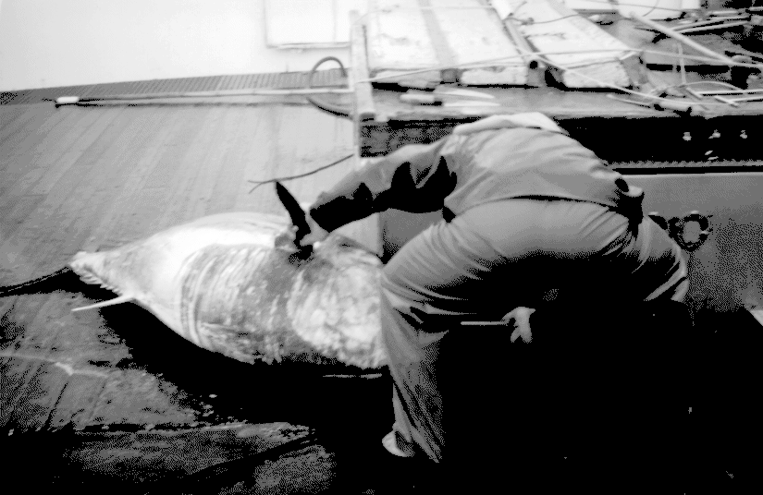
Dressing a "Jumbo" tuna.
I tiptoe into my cabin, shutting the door carefully -- Toru the Fishing Master is asleep. I am using one of three cabins on the bridge deck, just aft of the bridge. There is a navigation station and stairwell to the main crews quarters and three small wooden doors into the staterooms. I should mention that a six-footer would not be comfortable on this ship, as it is constructed for men of my size, definitely less than 5.8m. The Fishing Master has the best cabin, running the full width of the deckhouse. It has a bunk and a small settee and table. My cabin is identical with the Captain's cabin. It is 5' by 6'. Forty percent is bunk. Under the bunk are drawers. A closet, small refrigerator, bookshelves, more drawers, a dressing table and mirror occupy the remaining space. The actual floor space is less than three feet square. A single curtained porthole has a circular piece of cardboard fitted to keep out the morning light. When I wake up I first check for the thin crescent of yellow light on the curtain that means it is sunny outside. If it is there, I will definitely have a good day.

After one night on the tatami mats I indicated in gestures (amazing how much you can communicate that way) that I needed a mattress and they brought me a futon to fit the bunk. I hope it doesn't mean some one else is sleeping on the boards, but it was essential. I was severely sore in a lot of places after that first sleep. The futon is perfect and I sleep like a babe in the gently rolling night.

I have books with me. A novel by Joseph Wambaugh, a new book on the roots of consciousness, a large volume of Stephen King stories, and my French textbook. After the shift I read myself to sleep. It is very cozy and comfy.

Wed Jul 13 11:45:46 Tokyo (ship time) 1994

Yesterday was good tucker day -- sukiyaki for midmeal and curry for the late meal. We didn't do too badly on fish either, but the Fishing Master is still unhappy. The nearest boat, the Seiku 65, left for Hobart this morning. We still have 8.6 tonnes to go, which could take a couple of weeks. I will run out of sample bags today and data forms in less than a week.

Ship time is Tokyo time, which is one hour earlier than Sydney time. Our haul starts at 1230. I don't know when the crew sleep. With a 14-hour haul and a 5 hour set that doesn't leave much left over. I suppose that's why I don't see them around at other times.

I get tired after a few hours. Twelve hours on my feet is too much. It's better when there is something to do but often hours pass without a tuna, then there will be a flurry of them. The big ones are amazing, we had one last night that was 2 meters (over 6 feet) long and weighed in at 170kg (387 pounds).

The first few hours are fun and pass quickly. The weather has been beautiful -- sunny and calm -- and at 1500 I make a radio check with Taroona base. Then the sun goes down, first meal is eaten, and afterwards the long hours begin. Partly it is because everything closes in on the ship. It is dark out. The ship is lit up like a small city, literally with huge lights that are identical to streetlamps. It is as bright as day on the haul deck. Floodlights illuminate the incoming mainline with its clipped branch lines as it is wound in, matching the forward speed of the ship. It is cold and I am bundled up in my gear.

Fri Jul 15 10:48:27 Tokyo (ship time) 1994

At 1230 I start my 6th haul observation. I'm getting bummed out about this gig. Last night I bagged it with 120 baskets to go, the minimum observation. Most of the big fish and one swordfish were landed after I went to bed. It was cold and windy. It's worse today, Force 6 (25 knot winds) with swells I estimated at about 3 meters. The stressful part of this job is mostly the inactivity (a lot of sitting around on a cold windy deck waiting to write something down on a sheet of paper) and NOBODY TO TALK TO. The radio scheds are too formal. I miss human conversation, human warmth -- I'm such a stranger here. Nobody speaks my language, I'm not taking part in their activities, and the boat environment itself is weird and unnatural. It is easy in the daytime, up to the first meal break. After that I am on this brightly lit steel platform hurtling through the night, awash in blood and guts. Last night I noticed for the first time that the runoff from the deck comes out of a hull fitting below the main companionway. Leaning over the side of the ship I watched the red water discharge into the sea. I imagine working in an abbatoir would be the same. Beautiful creatures, sleek and shiny, processed into hollow carcasses, brains pierced, spinal columns reamed with wires, stacked and frozen for their long voyage to the Tokyo fish auctions.

Oh, I don't think we shouldn't kill and eat fish -- that's what the fish do for a living -- but this is so mechanical, so industrial, so Hitlerian in its design and execution.

After the second meal break, at about 830PM, it gets hard. Its colder, its windier, and I'm more tired. I sit in a corner by then, having some tea every hour or so, waiting until it is over, noting down the shark kill (there are one to two hundred sharks killed and dumped each day). Except for last night I've waited for the next to last radio beacon to come in and left with 240 hooks to go. I should do a full set some time.

I estimate seven to ten days before I get back to Hobart. I will have run out of books to read. I can always use the computer to do something, or study my French book, but I've bee running the the novels and stories, the ESCAPE fiction. I wish I could be back now. I've done this adventure. It does get easier, in some ways, to endure the long hours on deck, but I miss the home comforts and the ability to make decisions -- I think I'll go HERE, I think I'll go THERE. Can't do that here, there's nothing to do but the task. I wonder what it is like for soldiers, infantry men. I saw those specials on D-Day in Normandy. Where did they sleep at night? You always see pictures of them charging and fighting, riding on tanks. How did they get food? Did they use toilet paper? Did they have little tents and sleeping bags? Did they carry them on their packs? Hard to imagine all that.

It's time for lunch. Its like going to a restaurant alone. Everybody else is having a good time but I have no one to talk to.

I can't complain about the food. The only problem was this persistent dull headache which I figured might be MSG overdose so I've stayed away from the soups and broths and it has gone now. Yesterday we had omelettes for lunch and sushi for dinner. Excellent. Today was grilled "kippers" for breakfast (it may have been bait). We don't seem to eat any of the catch. Yesterday we hauled in half of a butterfly mackerel, a beautiful and large fish that is silver-scaled bright as a mirror when it comes aboard -- it was tossed back. No shark bait for our table!

I mentioned the sharks. They are very numerous. If they had been SBT I'd be home by now. Only 6.8 tonnes (6800 kg) of tuna to go -- another week. The sharks are mostly blue whalers -- a slender rather handsome shark. They come in all sizes, from 1 meter "babies" to 2.5 meters. They are blue on top and white on bottom and sort of a silvery color where the blue fades to white. The little ones might be tossed back but mostly a fisherman will cut the nylon leader (because its been abraded by the rough shark skin) and then stab or slice through the spine to kill it. In any case the hook is removed by slicing back from the mouth. Often the shark throws up at this point. The shark with its flapping sliced open mouth, is sluiced through a chute into the ocean -- food for its mates, no doubt.

It has clouded over and the wind has picked up. The ship has been hove to and is now making noises, as if it too is waking up. I think everybody is tired. I'm not going to like this, I think. Better dress warmly.

---

It is is very windy on deck with high seas. Every now and then green water sluices through the opening in the rail where the fish are brought on board. I've moved my observing station under cover forward on the port side of the haul deck. This deck is what we used to call a well deck on the scientific boat back at Oregon State University -- just in front and two levels below the bridge and one level below the main deck, just aft of the fo'c'sle -- it is fairly close to the sea to allow easy retrieval of the main and branch lines and hauling aboard of the catch. It is open on the starboard side with the mainline winder and three branch line winding machines. When a good fish (not a shark or other bycatch) is hauled in the fish is measured to the nearest centimeter against a ruler nailed to the deck, butted against one of two large hatch coamings in the center of the haul deck. These hatch covers form a kind of work table, holding various implements -- hammers, knives, saws (for gill-cutting of the biggest fish). The other hatch forward and under the roof is used as a worktable to repair or renew damaged branchlines. A square cauldron of hot seawater is nearby next to the port side. It is used for testing buoys, softening ropes, and mostly for dipping freezing hands in their waterproof gloves. Men taking a break sit on the edge so the heat rises into their backsides. After enough gloves are rinsed the seawater becomes soupy with fish slime and blood and the smelly steam wafts its way to my bench. When this gets too bad it is flushed with new cold water which must heat up again.

An insulated stainless steel Dutch-door below the bridge leads into the blast freezer. The men working there are dressed like Scott heading for the South Pole. They emerge rimed with ice, their eyes outlined by tiny ice droplets on the tips of their lashes.

Through the two freezer doors is an anteroom to the blast freezing compartments. The blast freezers operate at -56 degrees centigrade (that's 68 below for you Yanks). You start to ice up pretty fast in there. The frozen fish carcasses are stored on shelves and moved vertically with electric lifts. Below the blast freezer deck are storage freezers which keep the fish at ? degrees for the long trip home.

---

Just at dusk we catch a "jumbo" -- a branchline is unclipped and the fisherman holding it senses something on the hook. Quickly he connects a safety line to the end and begins to pay it out. As it is too big to haul in the bridge officer, who watches all of this from above, stops the ship. Another fisherman, then two more, grab the long bamboo-handled steel gaff hooks and poise themselves over the rail. The line now goes straight down into the water. What is on the end of the line is still very alive and very strong. Another crewman climbs the ladder to the main deck level and positions a long harpoon, this a brown fiberglass rod with a steel arrowhead on the end. A line fastened to the harpoon lies coiled in a box. The fisherman has a small platform to stand on where he can look into the sea. Deep in the ocean a roll of silver-green appears for a moment. The two men on the line pull it in, pay it out, compensating for the ships roll. The object on the line is gone again. They are careful to keep the pressure on, but not so much as to break the line. (When its obviously a shark on the line they don't care if it breaks, and often make a game of it, four or five men playing Volga boatmen with the line over their shoulders -- heave-ho heave-ho -- and drag that damned shark aboard). But this is precious sea gold they have on the line -- what they came all the way from Japan to find. Another silver roil appears. The men poise their gaffs. It has been a long time, about 10 minutes. The ship rolls in the swell. We can see the "jumbo" now. The crew is unusually silent. We wait. They must be careful. This fish could fetch forty thousand US dollars on the Tokyo market and must not be gaffed in the body. The harpooner quickly strikes -- literally a dead-eye shot to the head. The water turns red below my perch, the line is hauled in , and the gaffs reach down to hook the eye, the gills, the head. This is too big to haul in by hand. The huge winch-driven gaff hook is deployed to haul the tuna aboard. It is 183 cm, about six feet long, and weighs 129kg, which is almost 300 pounds. It is huge and beautiful and increasingly rare.

I must mention the sound of the haul deck. Ships are always noisy, of course, with generators and freezer compressors going full time, the main engine when under weigh, and the various hydraulics and conveyors. When the main line is being hauled there is a noise which is much like the T1000 theme from Terminator II. When the evil metamorphical robot from the future shows up there a thrumming UHHMMMMMMMMMMAHHHhhh, UHHMMMMMMMMMMAHHHhhh is heard in the background. That's what I listen to all night. The main engines sounds a throbbing LUB-A LUB-A LUB-A which continually pulses below all the deck noises. The smaller hydraulic branch line winders have their own peculiar click-WHIRRR sounds. It's quite a bit of noise in all.

I quit after the late meal. The weather is too rough. After the jumbo was landed there was not much tuna being caught, anyway. The sharks are killed by the dozens. Each shark requires a line on my form, "1945 BLW 5 D", which is the time, the species (Blue Whaler), a "5" for alive and active, and "D" for dead and discarded. If there were more fish I would feel better. But I sit on my bench bundled in my full-length survival suit like a maritime version of an orange-colored Michelin Man, pencil grasped in my yellow-gloved claws, waiting to fill in a line on my form. I am bored, bored, bored. I don't DO anything and this is driving me nuts. I can't do my tuna tagging because there aren't enough fish, or they are dead on the line or they are gaffed before I can stop them. The weather is bad and the fish few so there isn't much interest on the crew's part in gently landing a live tuna. If we were getting more fish, especially bigger ones, they might be more encouraged to let me tag the small ones, but they, like me, want to finish this job and go home.

The weather is very rough, seas are still coming in over the side. The fishermen get drenched and laugh. Haw ha, Kirshige got wet, haw ha. He laughs. They are nuts, I think to myself. I suppose if I did this for eleven months, and didn't slip over the side or fly home at the first port of call, I might get used to it. There isn't much to it -- the same fishing dance every night.
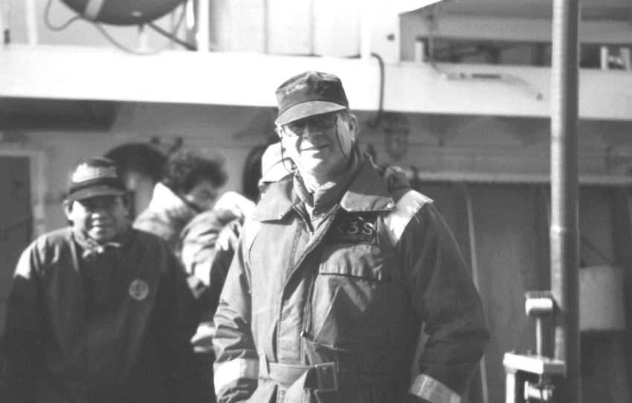
The Michelin Man Goes to Sea
I am also cold. It was fine when the weather was better but now I am shivering. I have two pairs of socks on, jeans, thermal undershirt, a sweater, a polar fleece pullover and a down vest. On top of this I wear a survival suit designed to keep me afloat and warm if I slip over the side (a tempting idea at times). I have a wool watch cap. This was OK in the beginning, but now I am cold, cold, cold. So I go to bed. Screw this job. So there. "All finiss?" asks the captain. "Showa?" Yes, shower and sleep, my captain. The ship shudders on through the night. I try not to feel guilty about being in bed while the fishermen do their sea-dance in the cold and spray. Heck, I think, I'm not a fisherman, what is this macho rubbish? I think I've made a big mistake here, volunteering for this gig. Its not much fun. I'm realising how much I need to talk to people. I think I like to be alone, but only if I have a telephone. I wouldn't last long in solitary, and a sensory deprivation tank would probably send me 'round the bend in short order. This is definitely one of the weirder things I've done in my life. I'll be glad I did it, but it is not fun. It has its moments, though.

Sat Jul 16 17:11:04 Tokyo (ship time) 1994

No fishing today. We are steaming for a point about 80 miles north and east of our previous fishing grounds. I think it was too rough to set the line last night. I talked to Donna at the regular 4PM radio check and she confirms that I will soon be in the vicinity of her boat, the Daikatsu 87. They are catching about a tonne per night with many small fish. Maybe I can do some tagging! We have about 6 tonnes to go before our quota is gone and we can go back. Donna says her boat has about 4 days to go and I could transfer, if the seas are right, to that boat. She will transfer to a third boat for more observer work (that's her job, after all). I can't wait to go home, but if it looks like its only another day or two I might as well stay aboard Kaigata Maru 86. I am settled in here, after all, and besides it would feel good to stay out my time in her. I just hope I can stand to work on deck. It will be rougher here, out of sight of land and no longer in the lee of Tasmania. I will have to wear ALL my clothes. I might stay warm, although I probably won't be able to move I'll be so bundled up.

For some reason my socks STINK after a day. I mean stink so bad I can smell them standing up. Now I've never had really smelly feet that I know of. Maybe it's the rubber boots I borrowed, or just sweating into them. I can only find two pairs of socks. Fortunately I can wash them every day in the ships "LANDRY" (as the sign over the door proclaims) if required.

We have arrived at our holding point. Engines are off and the ship is rolling in the swells. It's not too bad -- these are very stable ships. Good thing its not the old Bluefin. In two hours they will thaw the bait. I expect they will set as usual about 3:00 AM and haul in tomorrow afternoon at 1230. I've enjoyed having a day off, but not as much as the crew, I suspect, who probably have had their first good sleep in a long time. Of course, its one day more to go and 8 hours furthur away from Hobart.

Mon Jul 18 11:16:38 Tokyo (ship time) 1994

I was wrong. Yesterday's haul started at 0930 and lasted until 0020 the next morning. We had a couple of long line breaks. I went to bed with only 60 baskets left to haul at 1039 so the haul should have been done by midnight. I guess that's about right. They might have had another line break. We had two before I went to bed. When the line breaks and if the next buoy doesn't show up right away the crew all troops to the topmost part of the ship above the bridgehouse, where the radar mast is. Two huge searchlights, like opening night in Hollywood, are trained port and starboard and their beams rove around in the spray and dark looking for the flash of a buoy. It was very windy, about 30 knots I would estimate, and it took an hour to find the line.

For a change I was warmer than the crew. They are so active during the haul that the must generate lots of body heat. I am bundled up in my six layers of vests and sweaters with my insulated survival suit. One of the crew had given me an orange balaclava to wear, which is great as it keeps my neck warm. It also matches the grungy orange survival suit. However it comes with a big orange pom-pom on top, which was the cause of much merriment at my expense. These guys are a bit silly by now anyway. Anything will make them laugh. They pick up 6 foot sharks and pretend to copulate with them. They spray each other with hoses, drop a plastic bucket over someone's head and pound on it, and a big drenching wave is real knee-slapper.

The sea is amazing tonight. The swells are big and the ship is heading right into them. Normally the longline is set and retrieved so the starboard side, where the hydraulic winder is, is the leeward side. Now we are plowing into the big rollers and occasionally the bow plows up a monstrous sheet of spray. The crew ducks but the wind is so strong that it flattens out the spume and spray and whips it away before it can find us up here above the bridge. The searchlights pick out luminous streaks of wind-driven water. Useless to look, I think, I can't see a thing. The cook comes to call half of us to dinner.

---

We are still looking for the broken line. In this worst case the ship homes in on one of the radio buoys which occur every 40 baskets, each transmitting a distinct morse pattern. Finally the line is found but we there are two lengths to follow. I surmise that they connected the Number 12 radio buoy, cut the line, and followed the short end of it. When we ran out of mainline we doubled back to Buoy 12 using the direction finder and picked up the rest of the haul.

Now that we are more northerly we have been catching smaller fish and more of them, the kind I am meant to be tagging. However, because we have not been catching a lot of fish, the crew is not very interested in throwing back the small ones. We don't have enough big ones to trade off with. They all want to go to Hobart and feel that any tuna fish tossed back lessens that time. I want to go to Hobart, too, but I would like to do what I came to do. I learned this information from the captain this morning. Other things being equal, our ETA is next Sunday, 7 more days to go. I estimate 5 or 6 fishing days and a day of traveling. I'll talk to Mick Baron on the HF at the regular radio schedule and see if somebody can put some pressure on these guys. Donna suggested a fax from Japan Fisheries. Otherwise they may as well find me a boat going to Hobart and put me on it. I feel like I've been trapped in a nautical version of Groundhog Day, the movie where Bill Murray wakes up every day to find himself starting groundhog day all over again. This is the version with screenplay by Stephen King.

---

I just had my radio check with Mick Baron. I explained the difficulties with the tagging and he said that this late in the season it is a problem. I mentioned Donna's suggestion about pressure but he didn't know who might put the squeeze on. So it looks like I may get back to Hobart soon. The Taiyo 7 is in the vicinity and should be finishing up tonight or tomorrow night. Be prepared, he said, to leave on half an hour's notice. I shall have to find all the bags and pack everything. I should take the samples too. The funny thing is I have to remind myself how much I want to leave this boat. But I also want sail in to Hobart with the Kaigata 86! Why? This could take many days -- at least until Sunday -- since the fishing is so dismal. Something funny is happening. Why should I want to stay here any longer than necessary? Am I afraid of transferring ship to ship? The trip home shouldn't be more than a day or so.

Tue Jul 19 00:00:45 Tokyo (ship time) 1994

Midnight, ship time. I just finished the entire set. It took just about 12 hours exactly -- one of the faster ones. This is partly due to the paucity of fish, less than 400 kg, I believe. I will know exactly when I see the logbook in the morning, as I must have missed observing a few during radio and meal breaks. The Fishing Master, Toru, seems grumpy because of this. Other boats have been doing over a tonne a day. Hopefully Mick will arrange to transfer me to a Hobart-bound ship today or Wednesday.

During my watch I got a new pair of boots. I had mentioned that the ones that Mick had given me are thin and difficult to get on. The engineer, the man who had given me my tasseled orange balaclava, had also been watching my struggle to get in and out of my gear and came back with a brand new pair of padded and insulated japanese deck boots. The funny thing is that everybody else noticed immediately (or maybe it was a conspiracy) because if they were wearing identical boots they would lift them in the air and cry "same-u same-u".
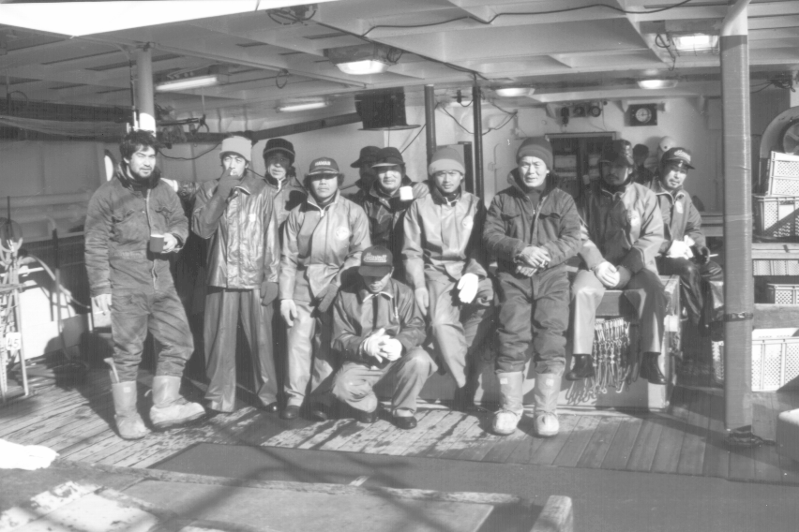

Our late meal tonight was spaghetti. "Rice, rice" they cried when didn't get my usual bowl. I couldn't explain that one carbo was enough. Watching a bunch of Japanese fishermen eat spaghetti with chopsticks was an unusual sight.

Tue Jul 19 10:09:50 Tokyo (ship time) 1994

I wake up as usual about 0730, testing the feel of the ship to see if we were in bad seas or good, looking for and finding my sliver of sunshine on the porthole curtain. The main engine is off so the set must be finished. I think the engine stopping probably woke me. I raise the cardboard insert and try to look out the porthole but brilliant light overwhelms my eyesight. I sneeze three times. Eventually, squinting, I can see it is calm and sunny. I finish the last Stephen King story. I am down to my last novel. Soon I will have my French text and the book on Consciousness, but I no longer feel such a need to escape.

I am becoming more accustomed to this, more adapted. For instance, last night I fixed the clipboard with pieces of monofilament leader to hold down the data forms and keep them from flapping, and made a tether for the pencil. The bench which used to be against the spare anchor on the fore bulkhead is always moved next to the hot water bath which allows me to see the deck but stay under cover. My mug, decaf instant coffee, tea and sugar are in a drawer under the hot water dispenser. The crew now know to let me check the gonads for the sex. "Boy Boy" they cry if it's male and, strangely, "Baby baby" or "Senorita" if it's female.

I hop out of my bunk, pull on my slippers, go down the ladder and head aft past the crew cabins to the mess deck. The cook is up and gives me one of his vitamin elixers, making masturbating motions. "Mastobate. Good" he says. Amazing. I drink it down. It tastes like a vitamin pill. I hope there is no caffeine in it. Off the mess deck is the laundry room with to WC's and a shower and bath room. I haven't used the communal bath. The first time I had to use the WC I picked the forward one which is the kind you squat over. I've never been comfortable squatting. I like to sit, preferably with a magazine, and let things ease out. Fortunately the other WC I soon discovered was a western type, with a seat. This is much better, if possibly less sanitary. I can't help it, I like a toilet seat.

It is such a warm and beautiful morning that I stroll around the ship, exploring nooks and crannies I hadn't seen before. I find a large storage chamber full of dried shark fins. They are not finning sharks on my beat. I had better ask Mick about this. On the horizon another Japanese longline is visible. The No. 7 Taiyo? My ride to Hobart? I hope so. I wish this boat were going back so I could stay aboard but we only caught a miserable 584 kg of Southern Bluefin last night. We needed 1000kg a night just to get back by Sunday! This rate could have the boat here another two weeks. This may be the biggest boat in the fleet but Toru can't seem to catch fish in a barrel.

I decide to check out the engineering spaces. They are on two levels. The compressors are on the top level, just below the mess room. They are big diesels that keep the blast and storage freezers running. They are all painted pale green. The walls are white and the deck is that cross-hatched aluminum plating. A can of Pepsi has been jammed into the rime of ice that coats the cooling pipes. There is no dirt, no oil or grease, anywhere.

One level below this is the main engine, a giant straight-six diesel. My old Ford stepside had a straight-six but this one is bigger than the whole truck. It, too, is pale green and, for now, is silent as we drift waiting for haul time. An diesel-electrical generator, which is never silent, rumbles away next to this behemoth. Everything is as clean and neat as before. Nobody is there. The machines are all alone.

Wed Jul 20 10:59:23 SYD 1994

I thankfully set my watch back to local Australian time. In three hours or less I will be back in Hobart. Last night, about 0100, Toru the Fishing Master woke me up from a very sound sleep to announce tell me "No 3 Ebitsu, Hobartu, Hobartu, 1 hour". Mick told me it would be like this, no advance warning. I busily packed everything away hoping I would not forget anything, and I don't think I did. Twenty minutes later as I passed through the bridge to get my old boots Toru poked his head in, "Hubba hubba, boat boat", and he pointed. In the near distance were the lights of another longliner and the small pulsing of a light buoy in the dark water. The floodlights picked out an octagonal rubber life raft with one man in it, floating. I decided I don't like Toru much.

I left a wrapped gift, a bit of Tassie blackwood (a tiny cutting board) for Toshio who had given up his cabin and I had wanted to leave the same for Captain Sakai, but he was sleeping. Maybe I can return later when the ship reaches Hobartu.

Waking up I experienced a muscle spasm in my right middle back. This happens now and then. Stress, excitement. I had to watch it as I don't want a cramp during the transfer. The Bosun was there to say good bye, as were the young Indonesian crewmen, and the engineer in pajamas who had given me the boots. Everything was together: sample bags, gear bags, GPS dismounted and stowed, pelican case with computer and camera, fruitless fish nabbing pole and dip net.

With the gear goes about half a dozen boxes of I-don't-know-what and a case of beer sent over by Toru. As the raft lifts in the swells the gear is tossed in at the top of each rise. A mustachioed seaman, very fierce-looking, is stacking it around himself as he sits in the lifeboat. This raft is becoming pretty full. There is just enough room for me. I manage to jump over at the BOTTOM of the swell, landing heavily on the inflated floor, but safe. Now I see the plan. We are tied to a light buoy. The Kaigata Maru 86 slowly steams off, it's steel walls sliding by our raft. We are left on the dark heaving sea. Slowly the other ship, the Ebitsu Maru No. 83 , gathers way and approaches us. A grappling hook is thrown to catch the line that ties us to the light buoy. New faces line the rail. The gear is tossed aboard and then I grab the rail. Hands help me to me feet. I look around. Not the same. This ship is different. The mainline winch and conveyer is in the same place, as it must be, but the work areas and ladderways are in a different place. Strange faces stand at different stations. I feel disoriented. They have obviously just finished their haul. The deck is littered with pieces of monofilament and mainline and the crew is all cutting and splicing and fixing. It doesn't feel like MY ship.

The show me to my "house", a cabin labelled "Officer" to port just above and aft of the haul deck. It has a bunk and desk -- bigger than the one I had on Kaigata 86, and it doesn't even look like anyone was booted out to give it to me. I try to sleep, but sleep comes slowly. I am very happy to be freed from my Sisyphisean labors on Kaigata, but I feel strangely depressed too, like I wanted to stay on the ship. I've noticed, these few days, that my moods were very volatile. I would stand on the deck, clipboard in hand, thinking "I'VE GOT TO GET OUT OF HERE", wondering how I could stand another 6 hours of observing, watching the clock creep slowly around, marking up yet another Blue Whaler shark discard every two or three minutes. Then at other times I would relish the strangeness of it all, the headlong rush into the night, the "click", grab and twirl of the crewman as he unclipped a branch line from the racing longline and in a single fluid motion pirouetted to the coiling machine, and the joy of being at sea.

All I can say is that "it has its moments", as does everything.

POSTSCRIPT

Thu Jul 28 15:45:04 SYD 1994

The Kaigata Maru 86 finally arrived in Hobart, about one week after I transferred off her. The bosun, some of the crew, and the captain were happy to see me. I drove some of them up to the souvenir shop in town. Toru was indifferent to my presence, as alway, slouching alone along the dock.

They stayed only until today so I had no time for a beer with my Japanese "mates". They are off to the Coral Sea to fish for yellowfin. The bosun presented me with another yellow pair of gloves a few minutes before the lines were slipped and the Kaigata 86 steamed out of my life forever.

